Finance & ACCOUNTING Office Manual

  - January 2026


Contents
I. Delegation of Authority – Finance and Accounting 3
A. Purpose and Scope 3
B. Roles and Responsibilities 3
I. Ongoing Tasks – As Needed or By Request 4
C. Issuing Payments – SAM Checks 4
D. Issuing Payments – OFAC Check 7
E. Issuing Payments – Tax Forms 8
F. Pay Wire/ACH Transfer Requests 8
G. Process Bill.com Payments 15
H. Receive Credit Card, Cash and Check Payments 20
I. Donation Management and Tax Letters 22
J. Post or Import JVs, CRs, CDs, and GL Transactions 24
K. Cash Management Policy 26
L. Petty Cash Payment 28
M. Reconcile and Post/Pay Expense Reports 29
N. Issue and Manage Staff Credit Cards 30
O. Process New & Closing Grants 31
P. Anti-Corruption Policy 31
Q. Procurement Policy 33
R. Internal Audits 34
S. Record Retention and Destruction Policy 36
T. Risk Assessments & Sub-recipient Monitoring 43
II. Weekly & Semi-Monthly Tasks 44
A. Altour Travel Report Entry and Reconciliation 44
B. Revenue Recognition 45
C. Grants Management Model 48
III. Monthly Tasks 50
D. Upload Field Reports 50
E. Post Cash Receipts 50
F. Post Bank Adjustments 54
G. Post Cash Disbursements 57
H. Prepare Divvy Expense Reports 60
I. Monitor Staff Expense Report Submission 60
IV. Quarterly and Semi-Annual Tasks 61
J. Categorizing Supplies, Equipment, & Other Capital Expenditures 61
K. Inventory Control Recording and Monitoring 62
L. In-Kind Contribution Policy & Recording 63
V. Annual Tasks 73
M. Prepare Documents, Reports and Schedules for Auditors 73
N. Prepare SharePoint Files, Etc. for New Year 74
O. Recording Depreciation 74
P. Financial Closing Cycles & Reporting 75
Q. Opening and Closure of Offices 76

Delegation of Authority – Finance and Accounting

Purpose and Scope
- This section establishes the delegation of authority (DOA) for all finance and accounting functions at Partners of the Americas (“Partners”). It is consistent with the requirements of 2 CFR 200.303 (Internal Controls), 2 CFR 200.305 (Payment), and 2 CFR 200.318 (General procurement standards), which require non-Federal entities to maintain written policies and procedures with adequate segregation of duties. The DOA applies to all transactions recorded in Sage Intacct, all payments processed in CashPro Online and Bill.com, and all financial reports submitted to donors and auditors.

Roles and Responsibilities

CFO/Controller
- The CFO/Controller bears primary responsibility for the financial integrity of the organization and holds final approval authority over all accounting and payment functions. Specific authorities include:
- Reviewing and approving all transactions (Journal Vouchers, Cash Receipts, Cash Disbursements) entered by the Senior Accountant before they are posted to the general ledger;
- Posting all approved transactions to Sage Intacct (the CFO/Controller is the sole person authorized to post transactions to the accounting software);
- Approving and releasing all wire/ACH payments in CashPro Online (the CFO/Controller is the sole person authorized to approve and release payments from the bank);
- Providing final approval for all bills in Bill.com before payment is released;
- Approving the In-Kind contribution entries per quarter;
- Providing the final fiscal year depreciation entry for posting to the general ledger;
- Authorizing new vendor setup, credit card issuance, and changes to credit card limits;
- Releasing award account code combinations upon new grant award;
- Providing draw-down confirmation and LOC documentation to the Senior Accountant for recording;
- Serving as the sole point of contact for delivery of internal financial information to external auditors (all documentation to auditors goes through the CFO/Controller first); and
- Approving written authorization for opening of field office bank accounts, together with the President of Partners HQ.

Senior Accountant
- The Senior Accountant is responsible for the data-entry and transaction-entry functions of the Finance and Accounting office. The Senior Accountant does not have authority to approve or post transactions independently. Specific responsibilities include:
- Entering all transactions (JVs, Cash Receipts, Cash Disbursements, wire/ACHs) in Sage Intacct;
- Entering wire/ACH payment requests in CashPro Online and submitting them to the CFO/Controller for approval and release;
- Uploading and coding invoices in Bill.com and routing them through the approval workflow;
- Printing Unposted reports and presenting them to the CFO/Controller for review prior to posting;
- Performing SAM.gov and OFAC compliance checks and retaining documentation with payment records;
- Receiving, processing, and uploading field office financial reports after CFO/Controller approval;
- Filing, and archiving posted documents in accordance with this manual and 2 CFR 200.334 record retention requirements; and
- Auditing incoming expense reports for completeness, proper coding, and supporting documentation per 2 CFR 200.430 (compensation requirements) and 2 CFR 200.474 (travel costs).

Segregation of Duties – Summary
- In compliance with 2 CFR 200.303(b), the following segregation of duties is mandatory and may not be circumvented: (1) The Senior Accountant enters transactions; the CFO/Controller approves and posts them – these functions may never be performed by the same person for the same transaction. (2) The Senior Accountant enters payment requests in CashPro; the CFO/Controller releases the payments – the person entering a payment may never be the person who releases it. (3) Any deviation from this segregation of duties must be documented in writing and approved by the President/CEO of Partners HQ.
- Ongoing Tasks – As Needed or By Request

Issuing Payments – SAM Checks

Suspension & Debarment
- Debarment and suspension are actions taken by the federal government against organizations or individuals who have committed fraud or a criminal offense in violation of federal law. Partners must certify that all vendors: employees, contractors and sub-grantee, etc. who have been suspended, debarred or charged with criminal activity will not be allowed to administer federal funds on behalf of Partners. In addition, it is Partners responsibility to ensure that any recipient of funds must not engage in transactions with, or provide resources or support to, individuals and organizations associated with terrorism. This policy applies to all officers, directors, shareholders, employees and appointed third party representatives of Partners (including but not limited to agents, intermediaries, sub-awardees, consultants, etc.) in all locations. Violation of this policy will be severely sanctioned.
- System of Award Management (SAM) Check
  - Any recipient of funds must not transact or conduct business with any individual or entity that has an active exclusion on the System for Award Management (SAM) (www.sam.gov). The list contains those individuals and entities that the U.S. Government has suspended or debarred based on misconduct or a determination by the U.S. Government that the person or entity cannot be trusted to safeguard U.S. Government funds. Suspended or debarred entities or individuals are excluded from receiving any new work or any additional U.S. Government funding for the duration of the exclusion period. Partners may disallow costs, annul or terminate the transaction, debar or suspend the recipient, or take other remedies as appropriate, if any recipient violates this provision.
- Partners will act immediately upon learning that any of its principals, at any time prior to or during the duration of an award:
  - Are presently excluded or disqualified from doing business with any U.S. Government entity;
  - Have been convicted or found liable within the preceding three years for committing any offense indicating a lack of business integrity or business honesty such as fraud, embezzlement, theft, forgery, bribery or lying;
  - Are presently indicted for or otherwise criminally or civilly charged by any governmental entity for any of the offenses enumerated in paragraph c.(2); or
  - Have had one or more U.S.-funded agreements terminated for cause or default within the preceding three years.
  - Principal means—
    - An officer, director, owner, partner, principal investigator, or other person within a participant with management or supervisory responsibilities related to a covered transaction; or
    - A consultant or other person, whether or not employed by the participant or paid with Federal funds, who—
      - Is in a position to handle Federal funds;
      - Is in a position to influence or control the use of those funds; or,
      - Occupies a technical or professional position capable of substantially influencing the development or outcome of an activity required to perform the covered transaction.
- Partners, in accordance with Federal regulation, requires that a SAM check be done on all recipients (individuals and entities) who are receiving any funds. Proof that the SAM check was done must be retained and kept along with proof of the payment. A SAM check must be complete prior to the recipient receiving any funds. The SAM check must be run at a minimum, once per calendar year (January – December). However, for all U.S. Government (USG) federal award transactions, a SAM check must also be performed prior to each new award, contract, or sub-award issuance, regardless of when the last annual check was conducted, in accordance with 2 CFR 200.318(h) and the Federal Acquisition Regulation (FAR). The entity must not be actively excluded at the time of any award or payment.

SAM Checks done Via Visual Compliance
- Prior to issuing the first payment to any individual or entity in each calendar year a SAM Check must be performed.
- Partners processes all SAM checks via a platform called Visual Compliance which provide a full compliance check.
- Prior to enter any payment on the system, make sure you have checked if the vendor has a Visual Compliance document uploaded; (Click on the top toolbar tab Maintain > Vendors and search for the vendors name - Once found double click on the vendor to view full profile. Click the staples image that says Manage Attachments to open the attachment box.)
- To Run a Visual Compliance Check
- Go to www4.visualcompliance.com/_logon.cfm and login
- Click the Search Records on the top toolbar
- Type in the name of the individual or entity you are going to pay and click search
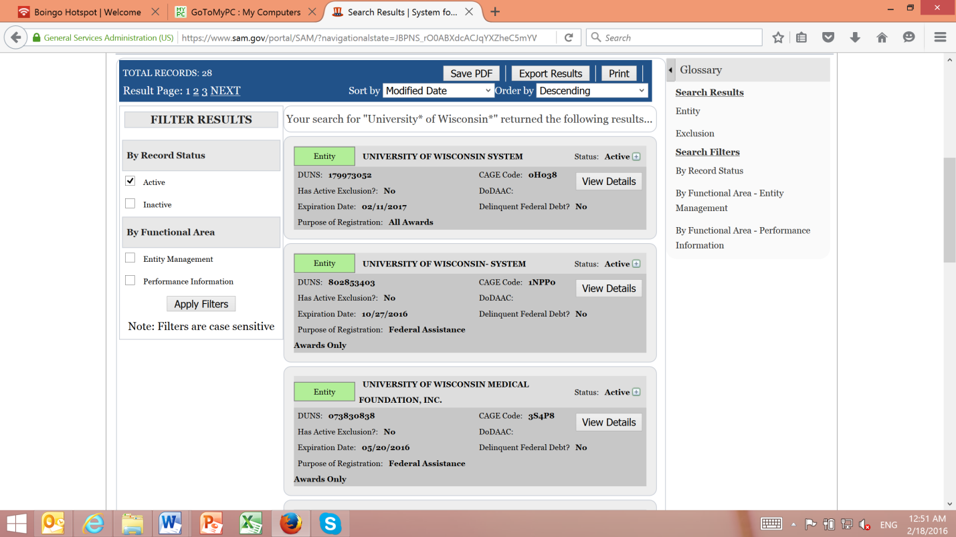
- No results or results with Green boxes for in compliance as shown below is fine:

- If box are red or purple, a more advanced search must be done in order to verify identity.
  - Click on the tab Search Records
  - Select the box on the right that says Advanced Search - Exclusion
  - Search by the individuals or entities name but also include their country or state to reduce the results are verify legitimacy of the payment
- Once positive results are obtain, click Save PDF.

Preventing Terrorist Financing
- Partners is committed to ensuring that its funds are not used to support terrorism or terrorist organizations. In addition to SAM checks, field offices must:
- Screen all new vendors, sub-recipients, and significant consultants against the OFAC Specially Designated Nationals (SDN) list at https://sanctionssearch.ofac.treas.gov/ prior to any payment under a USG award.
- Document and retain OFAC search results with payment documentation.
- Immediately notify the HQ F&A team if any potential match is identified. No payment may be released until the HQ F&A team and, if necessary, legal counsel, have cleared the transaction.
- Any individual or entity identified as a match must be reported immediately to the CFO/Controller and, as required under 2 CFR 200.213, to the relevant Federal awarding agency. The CFO/Controller is the sole person authorized to determine whether a payment may proceed following a potential SDN or SAM exclusion match.

Issuing Payments – OFAC Check

OFAC Check
- An OFAC Check must be run on all vendors, consultants, and sub-recipients prior to issuing any payment under a U.S. Government (USG) federal award, regardless of payment amount, in compliance with 2 CFR 200.318 and applicable OFAC regulations. For non-federal funded transactions, an OFAC Check is required for any payment over $10,000
    - Please reference procurement policy for additional details
- To Run an OFAC Check


  - Go to https://sanctionssearch.ofac.treas.gov/
  - No Username or password required
- Click the Search Records on the top toolbar
- Type in the name of the individual or entity you are going to pay and click search

Issuing Payments – Tax Forms

Vendor and Tax Forms
- Effective January 1st, 2016 an appropriate tax form will be required for ALL payments (all checks, wire/ACHs, etc.) made from Partners International Office.
  - The form will be required for all new as well as current vendors.
- These forms are only required for the first payment issued to each vendor every year, therefore once the form is completed in the current year, it will not need to be updated or verified until the beginning of the next year.
- The vendor form should be sent to each payee for all payment prior to submitting a check or wire/ACH request.
- The vendor will be responsible for completing the form and sending or scanning a copy to Partners
  - PARTNERS staff cannot sign or complete these forms on behalf of the payee.
- The vendor form must include a physical signature (electronic signatures will not be accepted). Each vendor form will need to be submitted with one of the following signed tax forms:
  - W-9 – For All US Based Individuals, Entities or Organizations
  - W-8BEN – For All Foreign Based Individuals
  - W-8BEN-E – For All Foreign Based Entities or Organizations
- Before the F&A Department finalizes any vendor payments, we will verify that an applicable tax form is in place. If not in place, the payment will return to the requestor of payment.

Pay Wire/ACH Transfer Requests

Entering Wire/ACHs into Sage Intacct
- In Sage Intacct, go to Basic Transactions > Enter Cash Disbursements. Press ‘+’ to get a new Session ID and enter your initials and a brief description Ex. Title: Wire/ACH Transfer MM/DD/YYYY your initials. Dates in title and date boxes must match. Cash Account: 1003 and click start
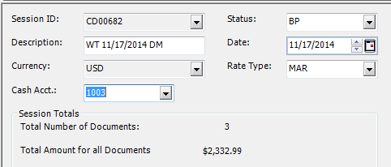

- Check: Wire/ACH number (Ex. W2422) – This number should be a sequence. Therefore, check the last payment Wxxxx before enter into Sage Intacct.
- Date: don’t change should match date released
- Enter amount, description, and payee ID
- Then enter line item information as shown on the wire/ACHs submission form (See below)
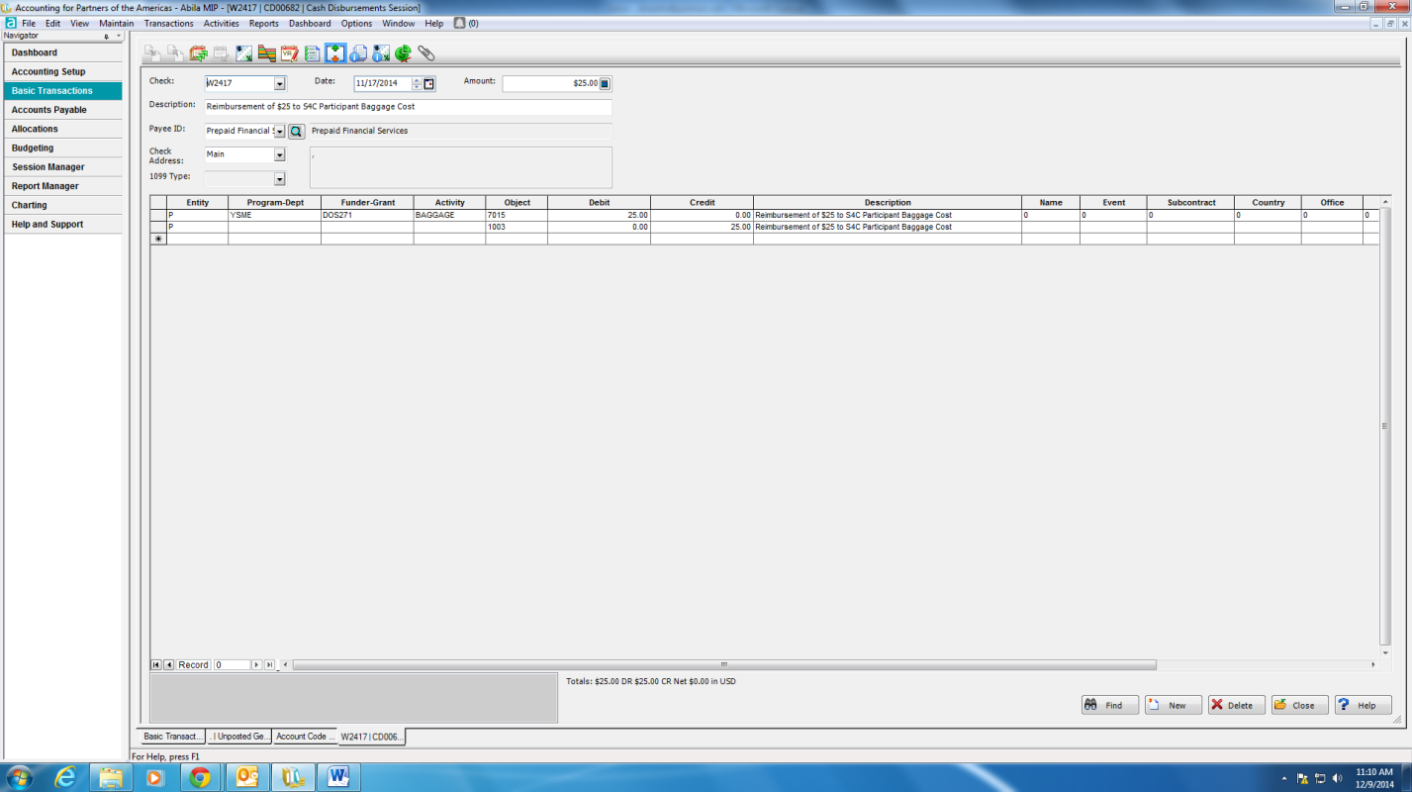
- ***Note: All wire/ACHs coded to 1203 follow coding below and only include Entity, Funder-Grant, Object, Amount and Description.
Example:
  - Entity: P
  - Funder-Grant: USAID648
  - Object: 1203
  - Amount: 30,000.00
  - Description: F2F Volunteer Guatemala for USAID648
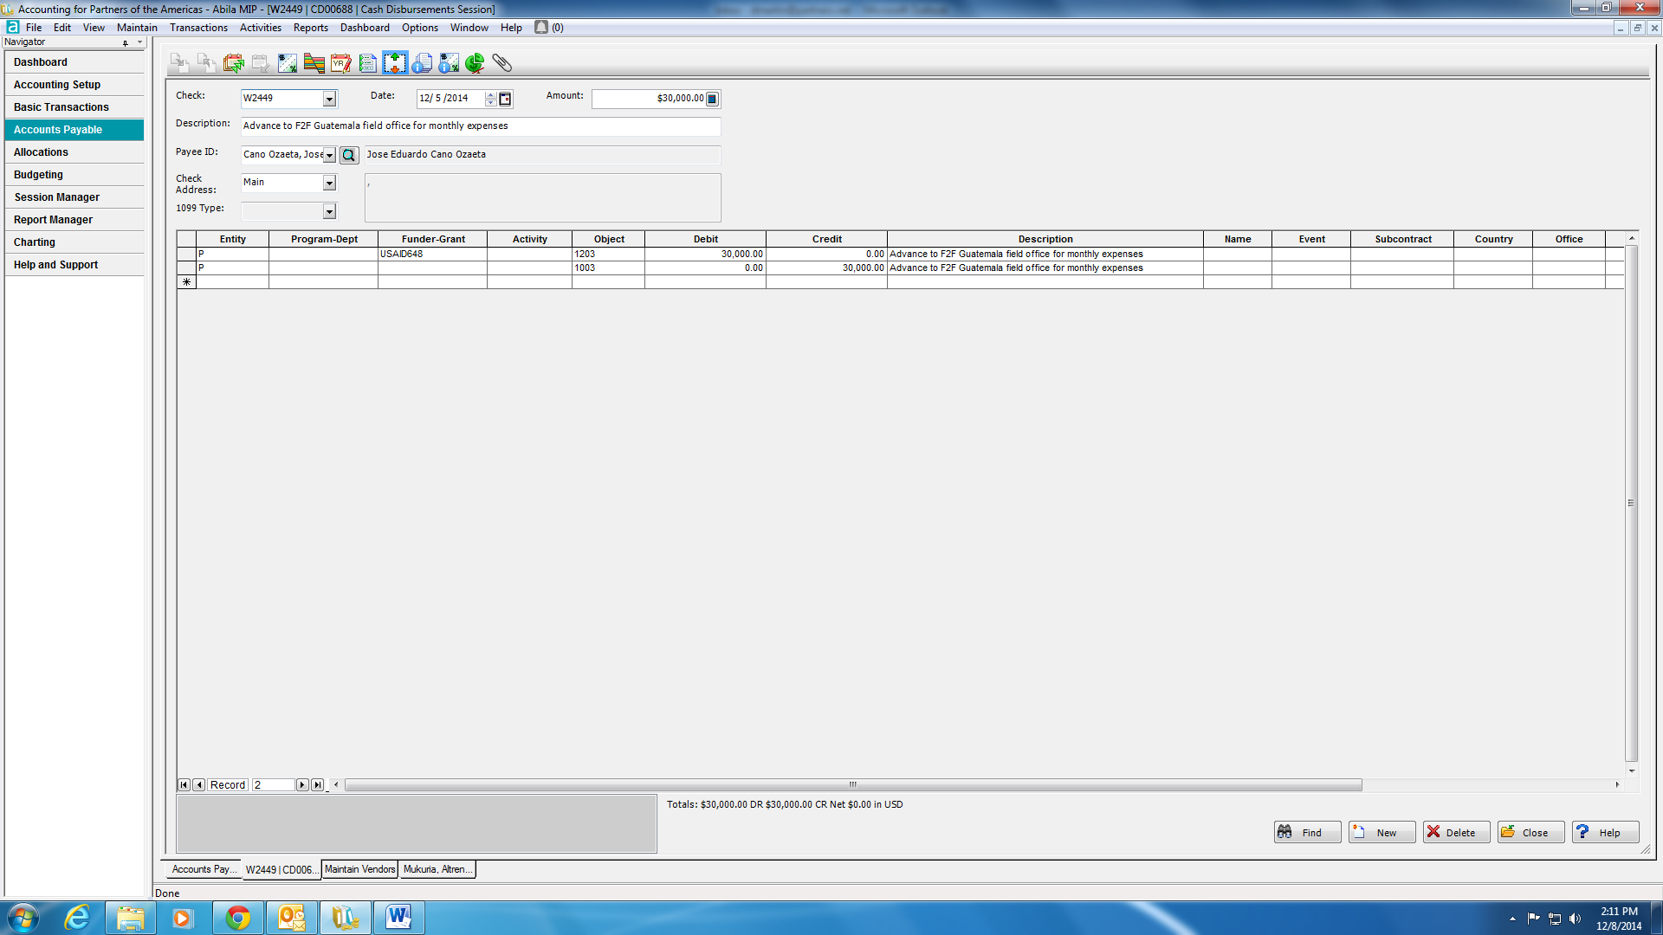
- ***Make sure to include grant number in description***
- Save document and proceed until all the wire/ACHs released that day have been entered.
- After the Senior Accountant has entered all wire/ACHs, the Senior Accountant prints the WT Unposted Reports and submits them to the CFO/Controller for review and approval prior to posting. The CFO/Controller is the sole authorized person to approve and post wire/ACH transactions in Sage Intacct, consistent with 2 CFR 200.303 internal control requirements.

Accessing CashPro Online
- Go to https://cashproonline.bankofamerica.com/AuthenticationFrameworkWeb/ cpo/login/public/loginMain.faces and enter your username and password.
- Company ID is PARAME04.


Entering Bank Information
- Separate out any requests for recipients that do not have a template set up already (non-repetitive wire/ACHs).
- Ensure full bank information has been provided for non-repetitive wire/ACHs.
  - For domestic transfers this would be at minimum the ABA (routing) number, bank account number and beneficiary name.
  - For international transfers this would be at minimum the SWIFT code (letters only), bank account number and beneficiary name.
  - For international transfer, check if there is an intermediary account.

Entering Non-Repetitive Wire/ACHs
- On the top bar click Payments > Payments Input
- Select the Debit Account – there is only one option (our checking account ending 2353).
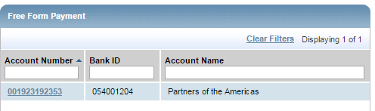
- Select the destination country, if not in the US the payment type is International High Value otherwise it is a Domestic High Value

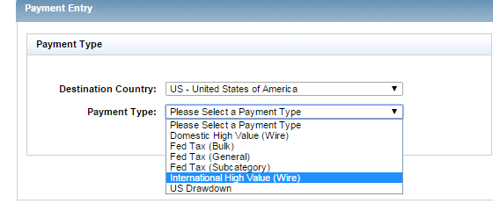

- Enter the Beneficiary Information, the Name, Address and City (Postal Code not required).
- Enter the Beneficiary Bank Information. For US transfers, this will be an ABA number, and for international transfers this will be the SWIFT Code. If Beneficiary Bank ID (Swift Code) is not found click search and select the swift code with XXX.
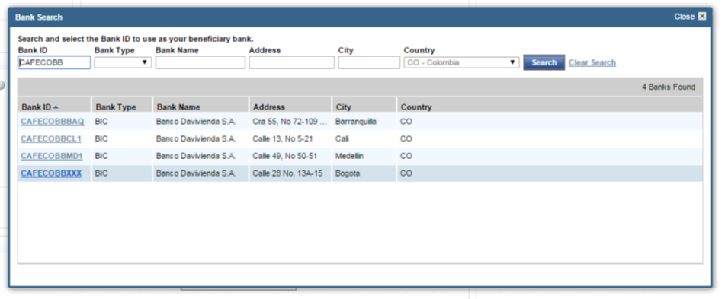
- Beneficiary email and mobile number should be blank
- Enter Credit Amount. In Sender Reference Number you should write the wire/ACH number (i.e. W0565). You can determine the next number available by viewing the check register in Sage Intacct (as long as all previous wire/ACH transfers have been posted), and also by checking the PDFs you’ve created of previous wire/ACHs. Be sure to record this number on the upper right corner of the request. Enter the description in the Beneficiary Information section.
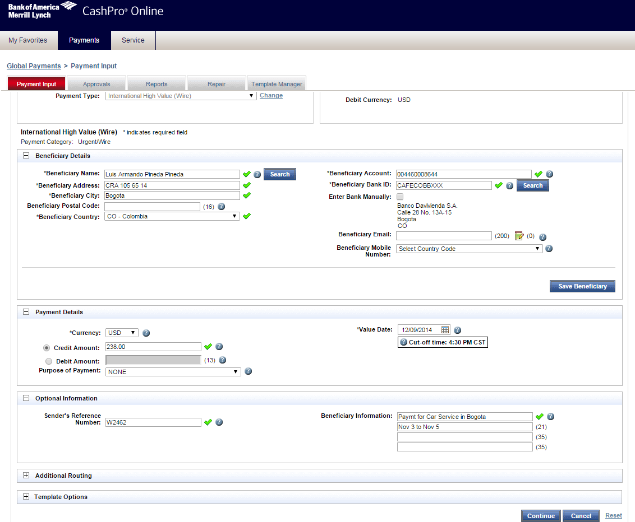
- If the recipient has provided Intermediary Bank information (international wire/ACHs only), click the Additional Routing button to drop down fields for that. Enter US ABA Number. Charges always shared. The bank information should populate accordingly (see image below).
- Enter the beneficiary and bank’s information in the Receiver Information section
  - //ACC/”type in account number” “description of account”
  - /”description of account”
  - /”individual’s name”
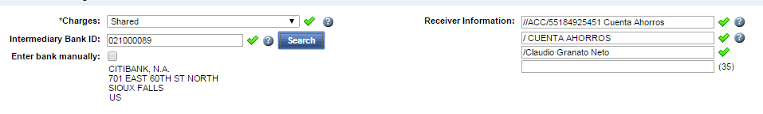
- Important: With foreign banks it’s fairly common that the money goes first to the bank’s account and then is forwarded to the recipient’s account. In this case, the recipient would provide two account numbers – the banks and their own.
- Once you have entered all the information correctly, click Continue. You will be brought to a screen where you can review the transfer, if everything is correct click Submit.
- Note if wire/ACHs are not approved before the cut off time of 5:30EST they will be under reports tab- need repairs. The dates must be changed to the following business day in order to be approved.

Creating Templates
- On the top bar click Payments > Template Manager
- Click the “Create Template” Button
- Select the Debit Account – there is only one option (our checking account ending 2353).

- Select the destination country, if not in the US the payment type is International High Value otherwise it is a Domestic High Value

- Fill in all the necessary information (see above for directions)
- In the pop up create an appropriate template code and name, they can be the same and click Save
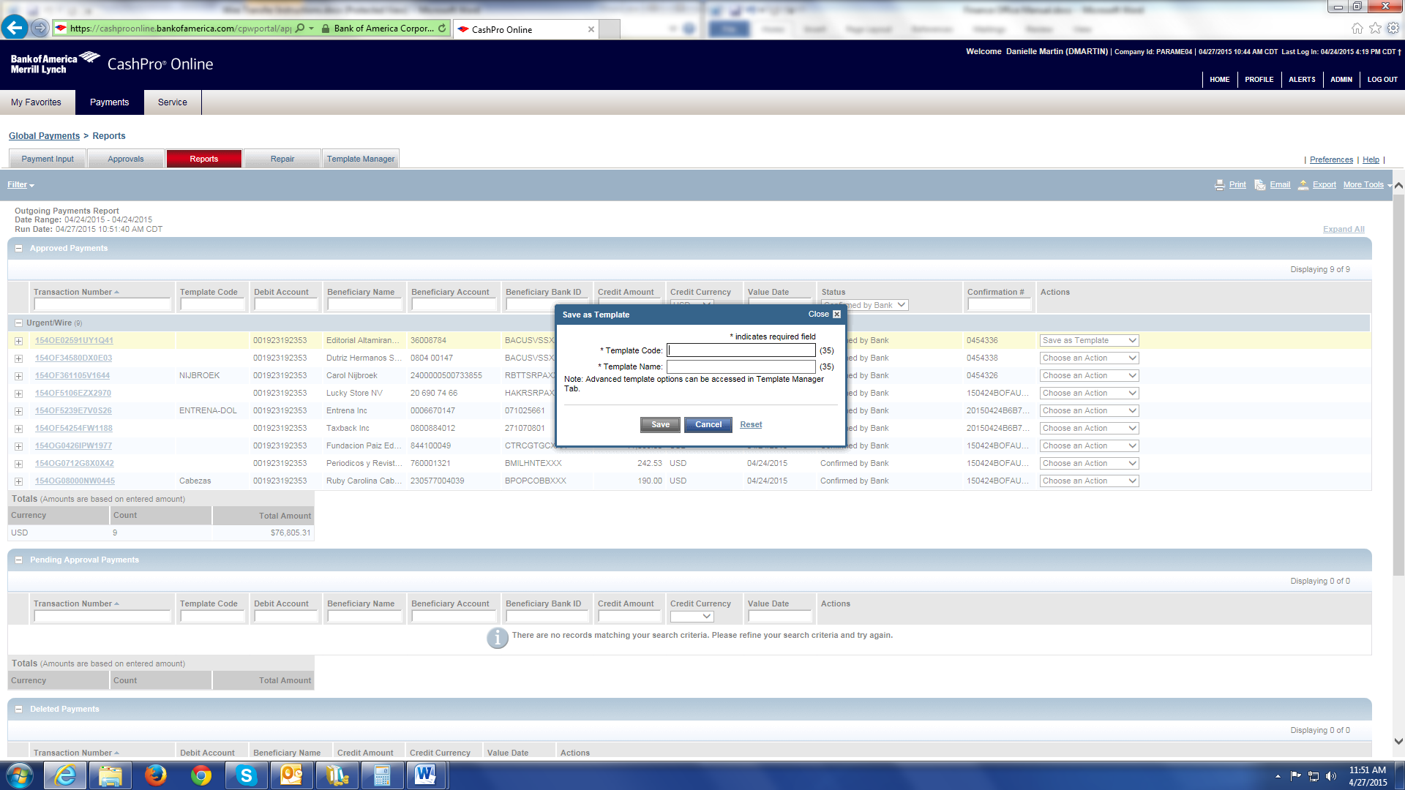
- Once you have entered all the information correctly, click Continue. You will be brought to a screen where you can review the transfer, if everything is correct click Submit.
- Next on the top bar click Payments > Approvals
- Select the template and from the drop down menu select Approve and Continue
- Verify that you want to proceed and click Submit and your template has been saved.

Entering Repetitive Wire/ACHs
- On the top bar click Payments > Payments Input
- Enter the Template Name and click Search.
- Enter the Credit Amount, Sender Reference, and Beneficiary Information. Be sure to record the wire/ACH number on the upper right corner of the request.
- Click Continue. Review your transfer, and if everything is correct click Submit.

Releasing Wire/ACH Transfers
- After the Senior Accountant enters all wire/ACH requests, the transactions must be submitted to the CFO/Controller for final review and release. The CFO/Controller is the sole authorized person to approve and release payments in CashPro Online (per 2 CFR 200.303 segregation of duties requirements). Go to Payments > Approvals
- All of the payments you’ve entered will be listed there for final review. Select from the drop down Approve on each transfer you’d like to release.
- When you’re ready to release, click Submit. You will be prompted to enter the 6-digit code from your SafePass card. Take your card and press the Press for SafePass Code button. A new code will appear in the window of the card, enter that number in CashPro and click OK.
- Once the number is accepted, the Release button will become active. Click that button to release the selected transfers.

After Wire/ACH Transfers are Released
- After the wire/ACHs are released, we must print confirmation pages to attach to each transfer for audit purposes, and in some cases for the recipient to use to retrieve the funds at the bank.
- Go to Payments > Reports. Select the report Outgoing for Current Calendar Day. A list of transfers will appear.
- The PDF copy should be emailed to the person who requested the transfer and anyone they listed to be notified.

Recalling Wire/ACHs
- If an error in submission or incorrect entry is made, you can attempt to recall the wire/ACH.

Update Wire/ACHs
- If for any reason the wire/ACHs did not go through and the approval date needs to be changed, the Senior Accountant repairs all affected transactions one by one, updating the date to the next valid business day, and resubmits to the CFO/Controller for re-approval before release.
- After that, you should submit the wire/ACHs for payment.

Process Bill.com Payments

Paying Invoice via Bill.com
- Use only Chrome as your browser go to www.bill.com
- Email – You company email
- Password – enter your bill.com password
- Click on Sign in

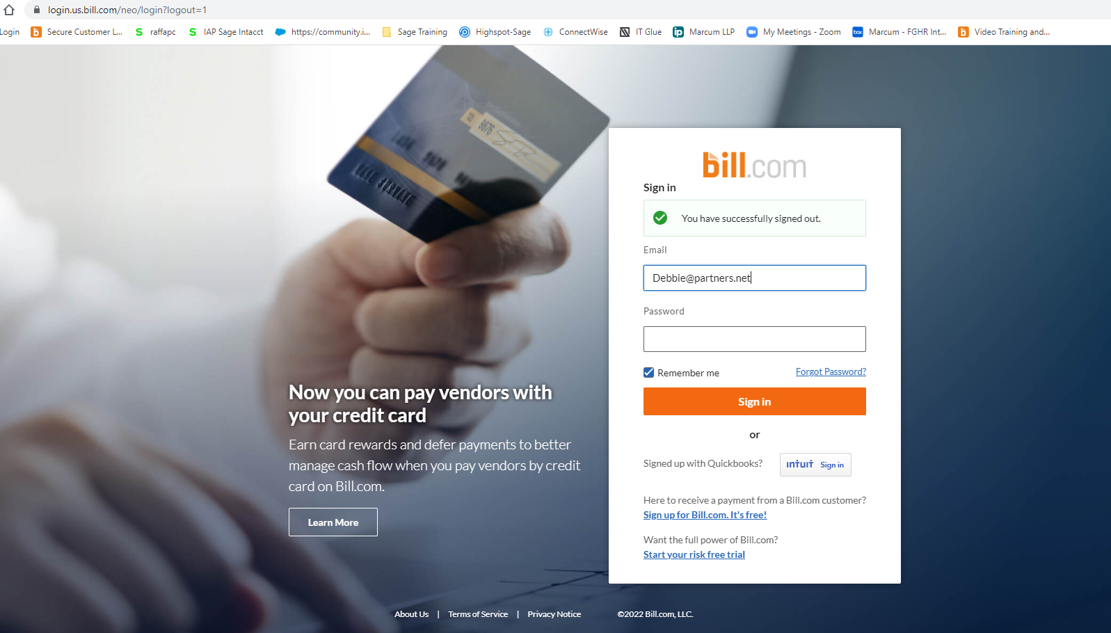
- Click on Partners of the Americas, Inc

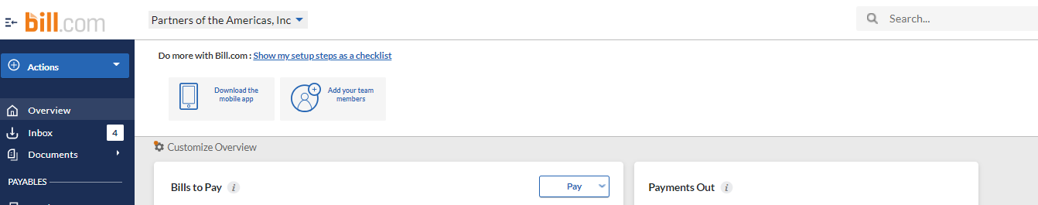

- Click on Inbox on the left blue bar

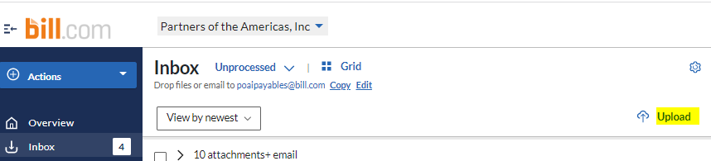
- Click on Upload as highlighted to the left and select the file from your computer that needs to be uploaded. All files need to be in one pdf document file to be uploaded. The file should include a summary cover page with all backup bills and supporting documentation attached behind it.
- Click open
- File should show up in the inbox and with a min your uploaded bills should be ready to be processed.
- Click Enter bill. On the top right as shown below

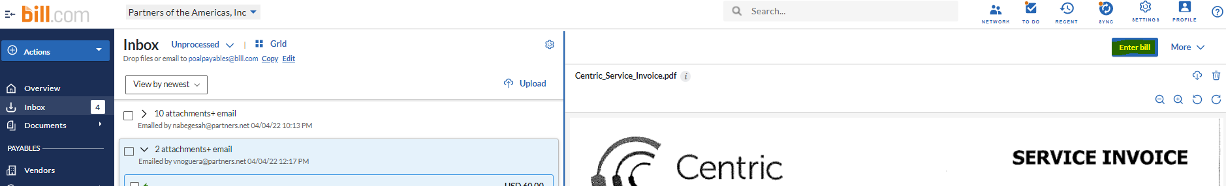

- Once you are on the enter bill screen, please verify the vendor, invoice number, amount, date and due date and other * marked fields as they are required fields to process the bill.

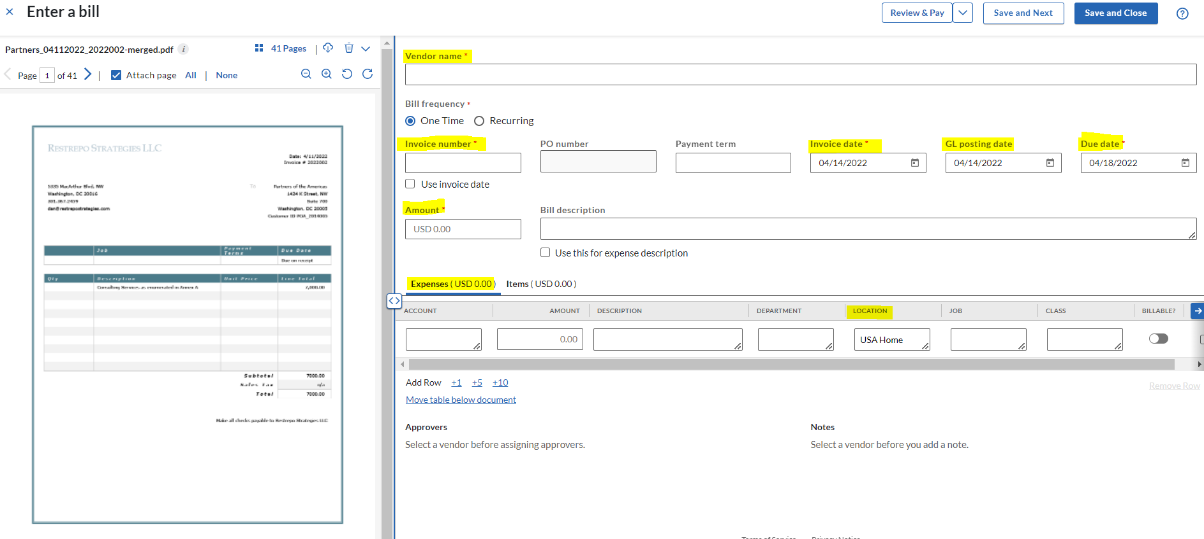

- Next step would be to fully code the bill with all the details of the expense
- Click on the Items tab

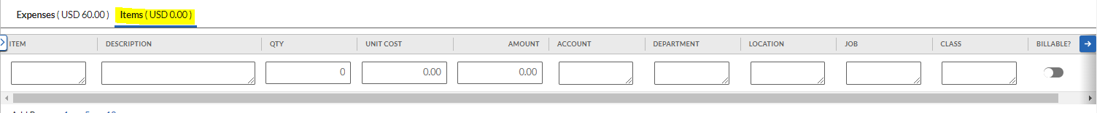
- Use Items are (the Budget) codes only if applicable
- Description – purpose of the expense using appropriate abbreviations
- Qty & Unit cost- can be skipped only.
- Total amount of the invoice in the Amount field if there is only one line for the expense.
- If the expense is coded in several lines, the total of all the amounts should equal the invoice total.

- Account – Please select the account name which best fits the expense in relation to the budget code.
  - Examples – 82401 Supplies, 87000 Training & Workshops
- Department - Please select the appropriate department from the dropdown list.
  - Example - 10192 Resource Development (92RD – Business development) or
10220 Operational (95O – Operations)
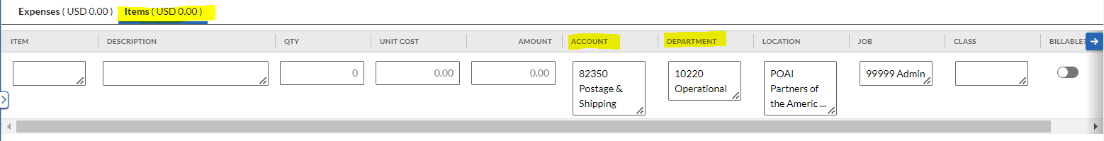
- In the Items tab please select the location as specific as possible and select the right Location under it.
- For example Home office would be USA Home office or select the country code abbreviation like MEX Mexico or any other applicable location relating to the expense.
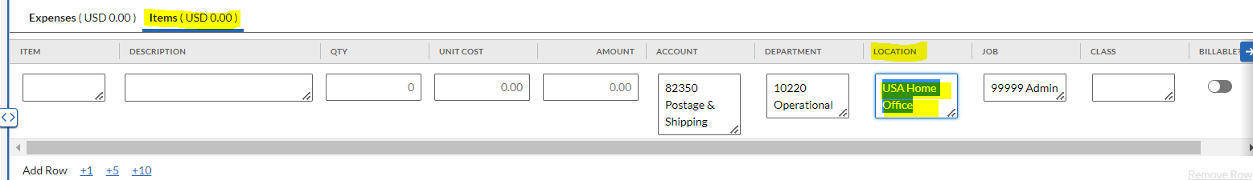
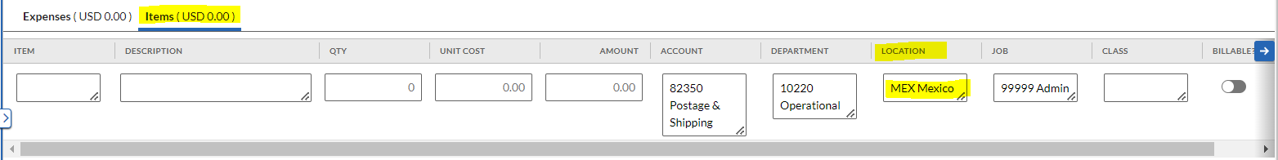
- Jobs/Programs/Award – Select the appropriate award from the dropdown. If the award is not shown in the list please reach out to Finance team to get the list updated.
- Example - USAID800 Juntos Aprende or for admin expenses or non-program expenses - 99999 Admin
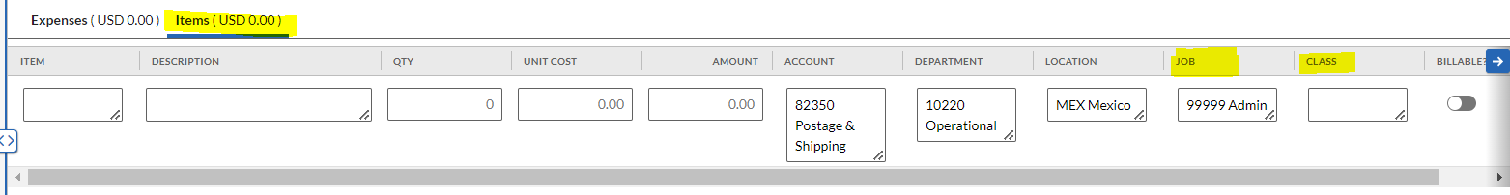
- Class- Do not use class field for any expense coding. LEAVE BLANK
- Billable – Do not use this field. Not applicable to expenses coding.
- In the Approvers section – The staff members enters the bill and codes all line items. The bill must then be routed for approval: (1) first to the program supervisor or budget manager, (2) audit by the Senior Accountant and (3) final approval must be provided by the CFO/Controller before any payment may be released.
- As shown below Debbie was added to the approval workflow at the bottom and move up as the first approver for the bill to be presented to the finance team for approval.
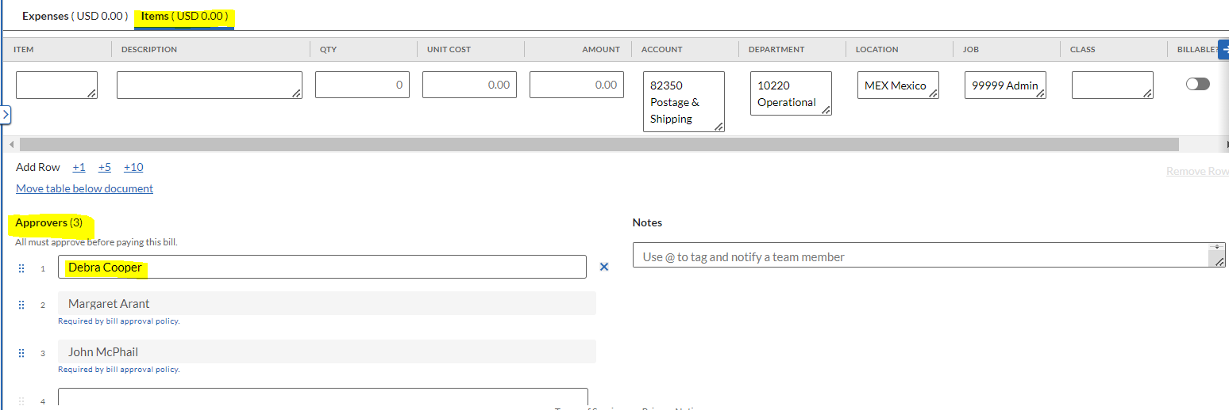

Notes – Additional review option for team members who are not involved in the approval workflow.
You can add anyone who needs to look at your coding of the expenses by using the notes section highlighted below.
You can use @ First name and then type the mesSage Intacct for the collaborator to get the mesSage Intacct. This will initiate an email to the collaborator to click on the link and look at the bill and reply back in case of any changes needed.
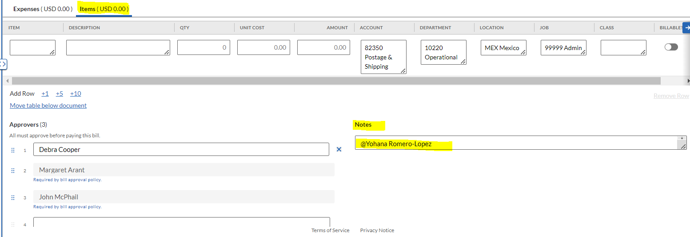

Receive Credit Card, Cash and Check Payments

Credit Card Payments
- To invoice someone from YM they have to be a member. To create members please ask the Membership team.
- Once someone is a member you can go ahead and invoice them.
- To create an invoice first log in to https://members.partners.net/admin/Login.aspx

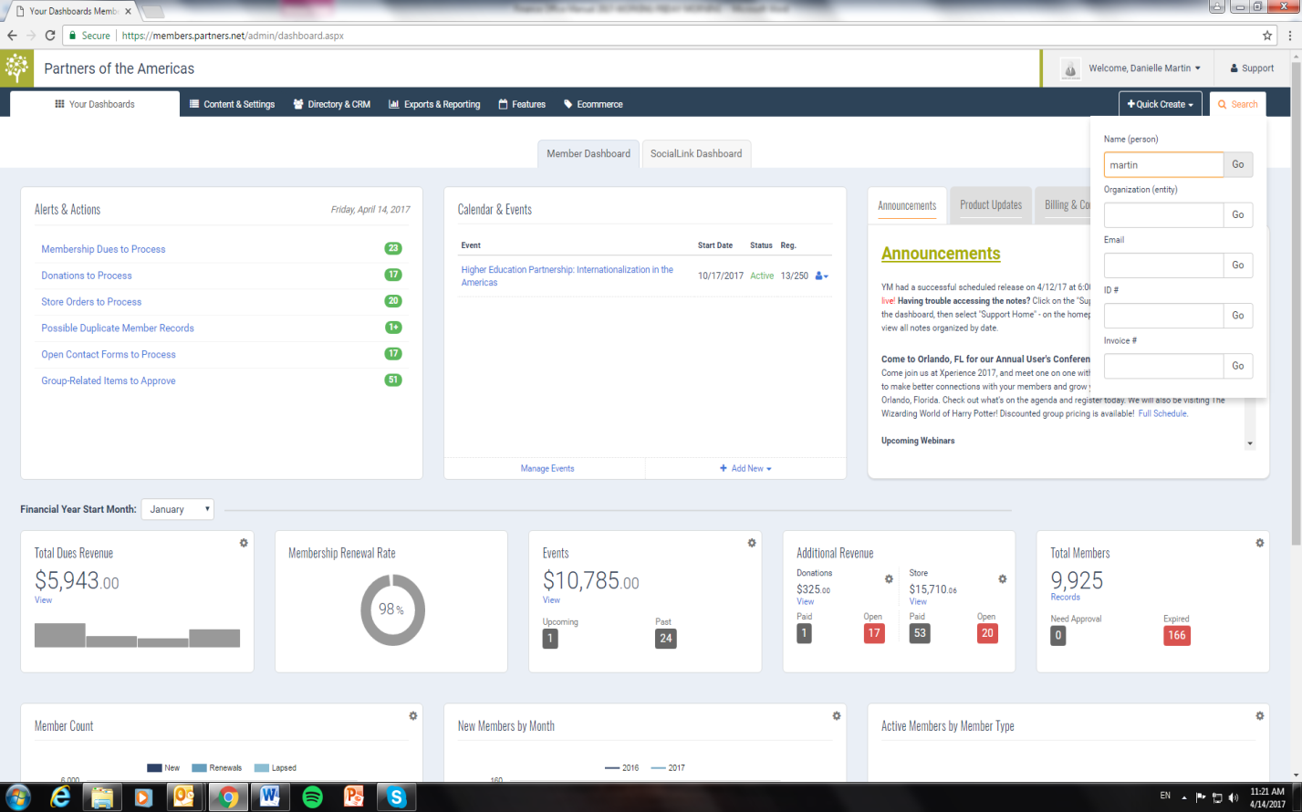
  - After login in please search the name of the member
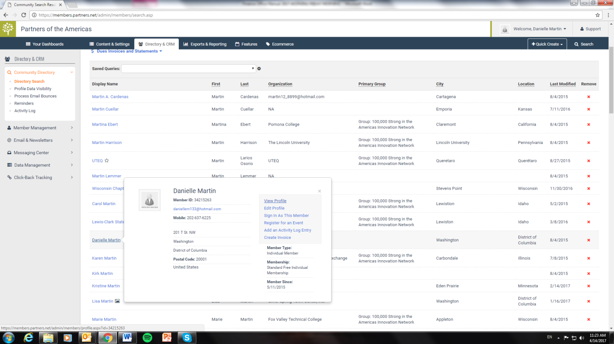
  - After searching the member right click on the name
  - Click view profile
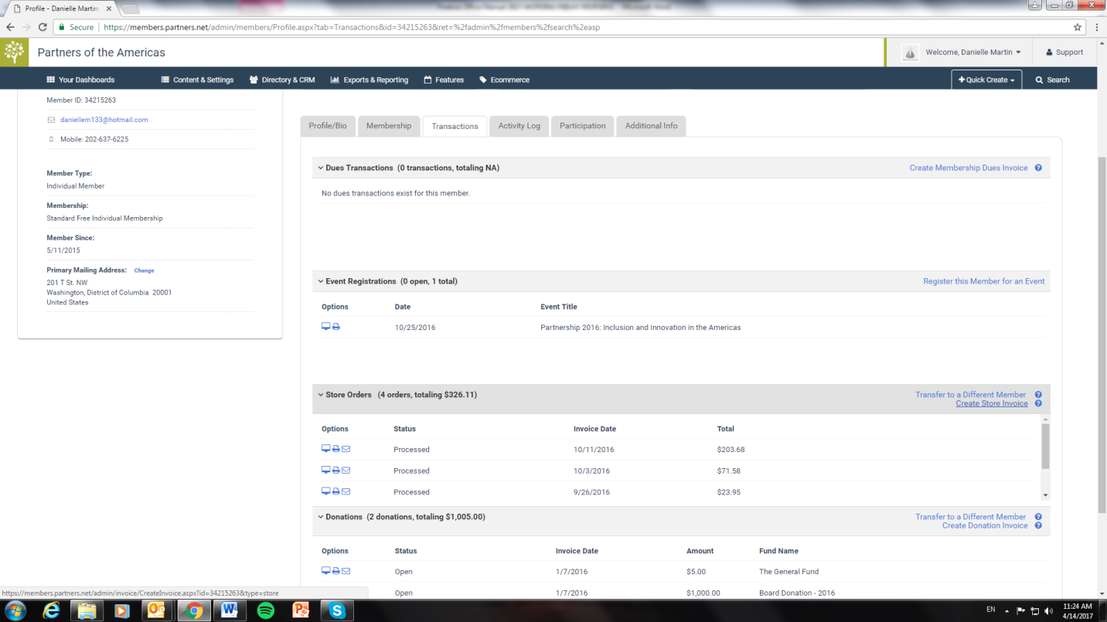
  - After click on transactions and then click create store invoice
  - Write a brief description of the charge
  - Enter Amount
  - Click generate invoice.
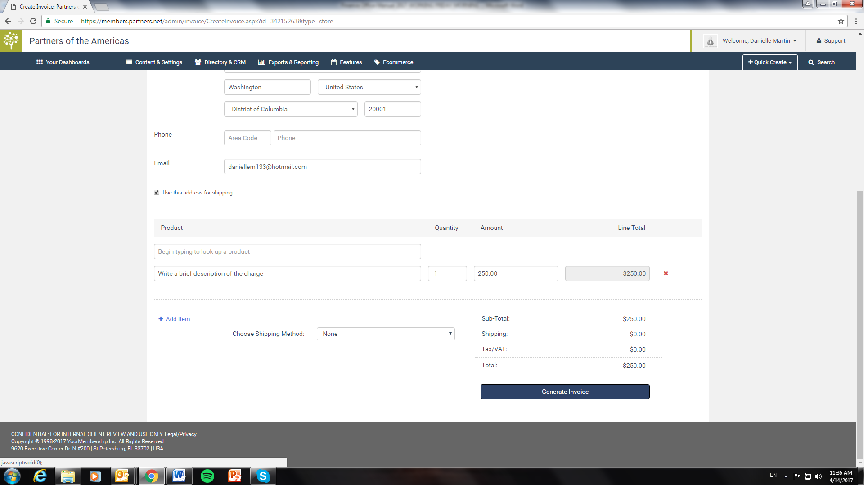
- Confirm the amount has been deposited into our bank account. All payments usually take 2 businesses day or longer on a weekend before hitting our bank account. At the end of the month you will receive a statement from Affinipay indicating the original payment amount less fees, which matches the amount deducted from our bank account for service fees.
- Once payment amount is confirmed, record payment received.
- These get posted in Sage Intacct as a Cash Receipts when entering bank receipts at end of the month.

Cash Payments
- Count cash and prepare receipt from 3-part receipt book.
- Payer is given the white receipt; yellow receipt is attached to cash and placed in safe.
- Record cash received on the 20xx PARTNERS Donations Spreadsheet on SharePoint.
- Will be processed as Cash Receipt after bank deposit.

Check Payments
- Checks will usually come in the mail, opened and distributed by the Finance Officer. If a check is given to you directly, make photocopies for the recipient(s) indicated on the envelope/enclosure and send the check and a copy to the Finance Officer.
- Attach a photocopy of the check before placing in safe.
- Will be processed as Cash Receipt after bank deposit.

Events
- Credit card swipe machines, carbon copy receipts and a cash box can be found in the kitchen to be used at events where money will be received.

Donation Management and Tax Letters

Donation Management
- The Finance Officer assists in the financial side of the donation management as it relates to all incoming payments.
- On a daily basis the finance officer will watch the mail for checks; if some are received two copies of the check are to be made. One will go to the finance officer to follow up with a donor thank you note, and other will be retained to include with Bank Deposits.

- If online donations are made the Communications Director and the Finance Officer will receive an email notification regarding the donation similar to below:

- Once this email is received the email will be forwarded to External Relations Manager to indicate that a donation thank you note should be sent.
- Next whether the donation was made online or via check, the donation must be record on the 20xx Donation Spreadsheet which is on SharePoint.
- The transaction should be recorded under two tabs: ALL and 20xx Donations
- Both the online and check donations will be recorded with the monthly cash receipts.

Tax Letters for Donations
- In the month of January the previous year’s donors should be mailed a donor tax letter indicating their total contribution total in the previous year.
- These letters must be in the mail by January 31st of each year.
- Please note that tax letters are only required for donors paying taxes in the US.
- In order to compile a list of individuals or entities requiring a letter, refer to the years’ Donation Spreadsheet.
- Select the 20xx Tax Letter List Tab to find of list of individuals and entities along with addresses.
- Customize the letter below accordingly.
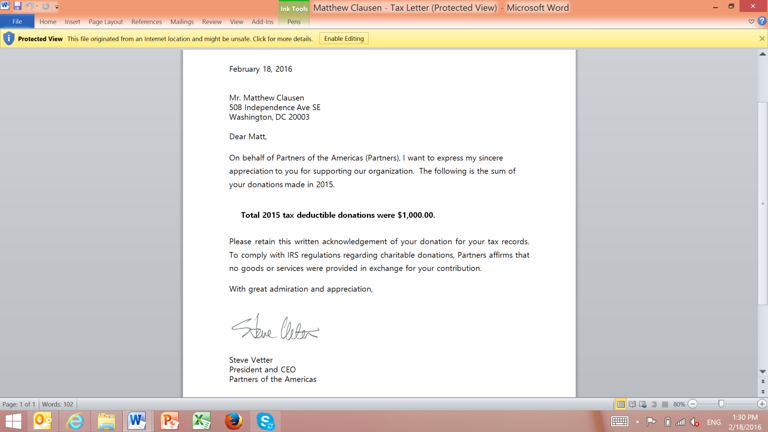
- Print and place in envelopes and put in the mail.

Post or Import JVs, CRs, CDs, and GL Transactions

General Guidelines for Sage Intacct
- When creating a new session, include your initials along with the description
- Review previous entries to see the formatting and help maintain consistency. Take advantage of the copy, reverse, memorize and distribution functions of Sage Intacct as much as possible to avoid unnecessary data entry.
- When entering, it’s always better to enter on the side of too much information. Our goal is that someone reviewing a report from Sage Intacct will have all the relevant detail, and won’t need to look up the original hardcopy unless absolutely necessary.
- After entering entries, print a copy using the Unposted reports and attach relevant backup or documentation. Journal Voucher and Cash Receipt documents should all be printed as separate reports, as they each have their own backup documentation. Wire/ACH transfers and AP Invoices can typically be printed all in one report since their backup will be filed in the filing cabinets.
- The Senior Accountant enters all transactions and prints the Unposted report for review. After the CFO/Controller reviews and approves the entries, the CFO/Controller Post the entries in Sage Intacct and files on SharePoint accordingly.

Entering Journal Vouchers
- Journal Entries can be written by anyone on the F&A team and placed in the Journal Entries bin. A wide variety of things may be entered as JVs, such as balance sheet adjustments, reclassifications, credit card expense reports and other manual transactions. The Senior Accountant is responsible for entering all journal vouchers into Sage Intacct. All JVs must be reviewed and approved by the CFO/Controller prior to posting. Only the CFO/Controller has authority to approve and post JV transactions to the general ledger, consistent with 2 CFR 200.303 internal control and segregation of duties requirements.

Entering Cash Receipts
- Cash Receipts will usually include incoming payments, bank deposits and Letter of Credit (LOC) draws from the government (documentation provided by the CFO/Controller). Occasionally we receive incoming wire/ACH transfers; these should also be entered as CRs.The Senior Accountant enters all Cash Receipts in Sage Intacct. The CFO/Controller reviews, approves, and posts all Cash Receipt transactions. The Senior Accountant may not post transactions without CFO/Controller approval.
- Although it is not a required field in Sage Intacct, you must enter a Deposit Number. Otherwise all CRs on the same date will show as one deposit. This procedure will help the bank reconciliation. Look at previous deposit numbers (either by report in Sage Intacct or hardcopies in binders) to ensure you do not have double numbers. Deposit Numbers are made up of the effective date, a dash and then a letter for each entry of the same date (i.e. 063011-A, 063011-B, etc.).

Entering Cash Disbursements
- After sending wire/ACHs, enter them into Sage Intacct as Cash Disbursements. The document number will be the wire/ACH number (i.e. W0656). Although it is not a required field in Sage Intacct, be sure to enter a Vendor for every wire/ACH transfer.
- Other non-check payments such as the corporate credit cards and pension contributions should also be entered as CDs. Look to previous entries for formatting.

Importing Journal Vouchers
- Save import spreadsheet as CSV. Review previous import CSVs for proper formatting, use these tips to format the import and troubleshoot import errors:
  - Copy and Paste > Values the entire spreadsheet before editing. Sometimes fields are linked and if you change the text of one you will lose the others.
  - Ensure all required fields are completed and all codes and combinations are valid.
  - Remove any foreign or accented characters. Shorten description lines with too many characters.
  - Format all dates as Short Date and all numbers to two decimals.
  - Sage Intacct can’t pick up lines without something in the first cell. If any necessary lines are blank or the first cell of the line is blank, type a random character in the first cell of the line. Be sure to delete all unnecessary blank lines above and below the entry.
  - You can open CSV files in Notepad to see any errors that might not be visible in Excel.
- In Sage Intacct go to File > Import. Be sure to choose the correct corresponding template before selecting the file to import.
- Open the imported entry and check for anything that didn’t import properly. Then process as a regular Journal Entry.

Cash Management Policy
- The following cash management provisions apply to all Partners offices.

Purpose and Scope
- Partners offices face multiple risks related to cash, cash equivalents, and checks. The best way to mitigate this risk is to keep funds secured, tracked, and recorded with proper internal controls to reduce the risk of fraud and ensure accurate recording in the general ledger.

Office Cash & Petty Cash
- As circumstances vary widely from office to office, local procedures and cash handling thresholds must be established for each office.
- An imprest petty cash system is used for day-to-day expenditures below a set amount as determined by the FO Finance Manager and approved by Partners HQ. Key requirements:
  - The Finance Manager maintains the petty cash log, controls access, and tracks all receipts.
  - No employee may access petty cash without documented approval.
  - When cash reaches a predetermined low level, the Finance Manager reconciles petty cash and replenishes via check payable to petty cash. All items are allocated to appropriate budget line items in the accounting software.

General Cash Handling Policies
- Below are the guidelines that Partners follows for all cash transactions.

Use of Safes
- All offices must use a safe for storage of office cash. Safes must be large enough to prevent easy removal, bolted down when possible, and kept in locked or barred offices. A primary key set is held by the cashier or cash custodian only; a back-up set is held by the Finance Director.

Establishing Minimum and Maximum Cash on Hand
- The Finance Manager, in coordination with the Finance Director and with approval from Partners HQ, must establish minimum and maximum cash-on-hand levels for each office and currency based on spending patterns and security considerations. Cash balances must not exceed the maximum threshold.

Minimizing Cash Transactions
- Given the inherent risks of cash handling, offices must always use checks or wire/ACH transfers whenever possible. A maximum value for any single cash payment must be established by the Finance Manager and approved by the Finance Director.

Evidence of Receipt by Payee
- All cash payments must be documented by a signed, numbered receipt prepared in duplicate, indicating the amount and date. One copy is given to the payee and one is retained with voucher documentation. This is required to prevent duplicate payments or disputed claims.

Periodic Cash Counts
- Cash balances must be physically counted periodically to ensure that journal balances match actual cash on hand. Guidelines:
- Counts must be performed by a minimum of two people (preferably an F&A staff member and the Finance Director) – one as counter and one as witness.
- Counts should occur at regular intervals and randomly, generally at least once per month.
- Any overages or underages must be recorded in the cash journal at month end. Discrepancies may not be carried forward. The cause must be investigated and reported to the Finance Director, who notifies Partners HQ for material discrepancies.

Bank Accounts
- Each office must maintain a bank account to receive project funds. Requirements:
  - Written approval from the President or CFO of Partners HQ is required before any bank account is opened.
  - Bank accounts must be held in the name of the entity and used only for the project’s purposes.
  - Each account must have a minimum of two signatories: the Finance Director and a Partners HQ staff member. An additional field employee signatory is recommended for checks and balances.
  - The Finance Manager, who approves all payments, cannot be a check signatory.
  - Any changes to account signatories must be approved by the Finance Director with notification to Partners HQ. Signatory information must be updated upon hire or termination of any signatory employee.

Monthly Bank Account Reconciliations
- All bank accounts must be reconciled to bank statements monthly in local currency or USD. Requirements:
  - An official bank statement must be obtained monthly for each account regardless of transaction volume.
  - The Finance Manager submits to Partners HQ: the bank reconciliation, copy of the bank statement, and full financial field report.
  - Partners HQ will spot-check expenditures and request supporting documentation as needed.
  - Prior-month outstanding items must be researched and cleared promptly.

Cash Flow Advances
- Offices may request up to 30 days of cash needs based on the monthly cash flow projection. Per 2 CFR 200.305(b)(1), advance payments to field offices must be limited to the minimum amounts needed and timed to be in accordance with the actual, immediate cash requirements. Advance funds must be deposited in insured accounts and, to the extent practicable, interest-bearing accounts. Per 2 CFR 200.305(b)(8)–(9), interest earned on Federal advances in excess of $500 per year must be remitted to the Federal agency. Partners HQ uses the reimbursement method as the preferred payment basis wherever the award terms permit; advances are used only where necessary to meet immediate operational needs.
- Cash flow advances must be cleared monthly through the financial report submission. Leftover funds must be taken into account when calculating the next month’s request.

Excess Cash on Hand
- Excess funds (cash exceeding 30 days’ working needs) must generally be transferred back to Partners HQ and the donor.

Petty Cash Payment
- Delegation of Authority: The Senior Accountant or local field accountant administers the petty cash fund and processes petty cash slips per the procedures below. The CFO/Controller or the local Finance Director establishes and approves the petty cash fund replenishment limit.
  - Per 2 CFR 200.305(b)(7), petty cash funds used for Federal award expenditures must be adequately documented with receipts or affidavits and reconciled regularly. Individual petty cash payments under Federal awards must be reasonable and allocable to the applicable award.
- Have the employee fill out a Received of Petty Cash slip with the date, description of the purchase, amount and coding information. Attach receipt if available.
- Give the staff member the exact amount of money indicated on the slip.
- Clip slip and receipt to petty cash envelope for reconciliation later (see other section).
- If someone asks for an advance from petty cash, be sure to record it so you can remember to collect documentation later.
- When a receipt is turned make sure staff member provides coding for the charge.

Reconcile and Post/Pay Expense Reports
- Delegation of Authority: The Senior Accountant or local field accountant audits and reconciles all incoming expense reports per the procedures below. The CFO/Controller or the local finance director provides final approval and posts the resulting JV entries.
- Audit all incoming expense reports whether for volunteers or staff. Expense reports without submitter signature, approval or proper coding should be returned to the submitter.
- All expenses $25 or more must have a receipt or affidavit attached.
- Check that the transactions add up, conversion rates make sense, and that totals match the credit card statement if appropriate. This is more important for volunteer expense reports (which are entered as lump sums) rather than staff expense reports that are entered line-by-line into Sage Intacct (math errors are more likely to be caught that way).
- Ensure no unallowable charges are reimbursed, such as alcohol. If accidentally included, deduct the amount from their total and note the deduction on the report. Per 2 CFR 200 Subpart E (§§200.420–200.475), all costs charged to Federal awards must be allowable, allocable, and reasonable. Common unallowable costs include but are not limited to: alcoholic beverages (§200.423); entertainment (§200.438); fines and penalties (§200.441); fundraising costs (§200.442); goods and services for personal use (§200.445); and lobbying (§200.450). The Senior Accountant must flag any questionable cost to the CFO/Controller before posting. Unallowable costs that have been erroneously charged to a Federal award must be reversed and charged to an unrestricted account; the CFO/Controller must notify the relevant program manager and document the correction.
- Once completed, sign your name as Audited By and date the form. The Senior Accountant then forwards the audited expense report to the CFO/Controller for final review and approval. The CFO/Controller approves the report and posts the corresponding JV in Sage Intacct before any reimbursement payment is made. Per 2 CFR 200.430(i), all salaries and wages charged to Federal awards must be supported by records that accurately reflect the work performed. Partners requires that employees whose compensation is charged (in whole or in part) to a Federal award maintain timesheets or equivalent documentation showing the time devoted to each award. These records must be signed by the employee and approved by a supervisor with first-hand knowledge of the work performed. The CFO/Controller is responsible for ensuring that time-and-effort documentation is complete and on file before payroll costs are posted to any Federal award account. Retroactive changes to effort allocations require written justification and CFO/Controller approval.

Issue and Manage Staff Credit Cards

Bank of America Visa
- To request a new card, have staff member complete New Cardholder Set-Up Form) and a copy provided to the Senior Accountant in color and scanned over in color. Card limit should be determined in coordination with supervisor and CFO/Controller depending on program need and level of responsibility.
- The form must be signed by an authorized person CFO/Controller and emailed to ccs_team_servicing@bankofamerica.com
- All other requests (add/remove authorized persons, cardholders, change limits, card closures etc.) must be submitted by authorized person to the same email as above.
- The request form and documentation of supervisor and F&A approval (emails are sufficient) should be given to the Finance Officer to be filed in the employee’s personnel file.
- Overall question enquiry and account management overview can be done online as well at https://globalcard.bankofamerica.com/sdportal/home.view - login and view reports, current spending amounts, etc.

Managing Employee Termination and Credit Cards
- Make sure employee has turned in all credit card report, expense reports, and Visa card. Process all reports before employee leaves.
- To close out a Visa card send an email to Visa at ccs_team_servicing@bankofamerica.com
- Cut up the card and toss file the email confirmation of the closed Visa card and file in the employee’s folder.
- Once done, send email to HR Officer and employee’s manager once you have fully processed the very last expense report and closed out the Visa card.
- Print that email and file in the staff folder.

Delinquent Employee Credit Cards
- All employees are responsible for submitting their credit card reports to F&A by the due date set each month. Employees will receive the months’ credit card report the last week of that month to submit by the due date (typically 2-3 weeks after distribution date). If an employee will be on Leave or Travel and not able to comply with the due dates, they must inform F&A in writing and provided a date they will submit their report.
- If an employee fails to comply with the above guidelines and the due date has passed, the Senior Accountant will send a First Warning email notifying the employee and their supervisor of the delinquency.
- If the delinquency continues after the First Warning. A Second Warning email will be sent. This email will be sent to the employee, their supervisor, and to the CFO/Controller.
- If the delinquency continues after the Second Warning. A Third Warning email will be sent. This email will be sent to the employee, their supervisor, and the President & CEO.

- If the employee fail to comply with the two warning emails and are outstanding more than 2 months statement (about 60 days) the credit card will be place on hold so no additional charges may be incurred. Once the employee submits ALL outstanding statements the card will be reactivated for use. To place a hold on the card send email to ccs_team_servicing@bankofamerica.com including the card holder name, last 4 of card, and instructions to temporarily hold the card. Holds may be placed/removed on cards per request from a program administrator via email. There is no form or letter required.

Credit Card Probation
- If an employee has their credit card suspended due delinquency, they will face a probationary period upon reactivation of the card. The employee will be placed on credit card probation for 6 months following the occurrence.
- During the 6 month probationary period, if the employee is delinquent on ANY statement, the card will again be suspended until the statement can be submitted. Once an employee has their credit card suspended twice within a 6 month time period, a permanent record will be filed in their personnel file. If the employee has their credit card suspended three times within a 6 month time period, the card will be cancelled. The employee will be re-eligible for a corporate card after a year. There will be no exceptions.

Process New & Closing Grants
- When new grants are won, the CFO/Controller will release a list of account code combinations to be created in Sage Intacct. The Senior Accountant creates the new account codes in Sage Intacct upon written authorization from the CFO/Controller. Sometimes this might require new activities or chart of account codes to be created.
- When a grant closes and activity related to the grant has ended, make any related grant or department codes inactive in Sage Intacct. After a year of inactivity it is usually safe to delete or discontinue the codes so no activity is accidentally allocated to a closed grant.

Anti-Corruption Policy

Purpose and Scope
- The Anti-Corruption Policy outlines the principles that Partners HQ, its field offices, and affiliates follow to achieve zero-tolerance against bribery and corruption. This policy applies to all officers, directors, shareholders, employees and appointed third-party representatives of Partners HQ and all field offices (including but not limited to agents, intermediaries, sub-awardees, and consultants) in all locations. Violation of this policy will be severely sanctioned.

Responsibilities
- All staff, contractors, and sub-grantees of Partners HQ are responsible for:
  - Enforcing the Anti-Corruption Policy;
  - The preliminary assessment of suspected corruption; and
  - Notifying the HQ F&A team if they are aware of any corrupt activities as required by this policy.
- The HQ F&A team is responsible for:
  - Assembling the inquiry team;
  - Monitoring the progress of the inquiry;
  - Preparing the inquiry report, including recommendations to prevent future occurrences and for recovery of losses, if any;
  - Reporting the results of the corruption inquiry to Partners HQ; and
  - Ensuring the implementation of the internal inquiry report recommendations.
- The CEO/President is responsible for:
  - Notifying and communicating with the Board the outcome of any inquiry;
  - Ensuring the inquiry team is independent and has access to adequate technical expertise;
  - Reviewing the inquiry plan to ensure it addresses all areas necessary for resolution of the allegations;
  - Monitoring the progress of the inquiry;
  - Approving the final internal inquiry report;
  - Approving any terminations of staff as a result of the inquiry; and
  - Ensuring recommendations in the final internal inquiry report are implemented.

Protection from Retaliation
- An employee who has reported questionable conduct and who subsequently believes they have been subjected to retaliation of any kind is directed to immediately report it to the FO Director and, if applicable, Partners HQ. Reports of retaliation will be investigated promptly. Partners HQ strongly disapproves of and will not tolerate any form of retaliation against employees who, in good faith, report issues regarding the misuse of Partners HQ or field office assets. Any employee who engages in such retaliation will be subject to discipline up to and including termination. Per 2 CFR 200.113 (Mandatory Disclosures), Partners must disclose, in a timely manner, to the Federal awarding agency or pass-through entity any violations of Federal criminal law involving fraud, bribery, or gratuity that may affect a Federal award. Failure to make required disclosures can result in suspension or debarment. All staff are required to report known or suspected fraud, waste, or abuse involving Federal funds to the CFO/Controller, who is responsible for determining whether a mandatory disclosure to the Federal awarding agency is required. Employees who make such reports in good faith are protected from retaliation under the terms of this policy and applicable Federal law.

Procurement Policy

Purpose and Scope
- All offices must adhere to the procurement requirements of Partners HQ as set forth in the Procurement Policy. All procurements must be made in a manner that provides maximum open and free competition, ensures cost and price analysis are conducted, and includes appropriate contract clauses that protect the organization and the Federal award.

Procurement Policy – Field Office Application
- All field office procurement decisions must comply with 2 CFR 200.318–200.327 and the PARTNERS Procurement Policy. See full Procurement Policy for all the details.

Procurement Process
- The standard procurement process involves the following steps:
- Step 1: Identify Need – The requesting staff member or unit identifies the goods or services required and prepares a written request with specifications.
- Step 2: Determine Procurement Method – Based on the estimated value, determine whether micro-purchase, small purchase, or formal competitive procurement procedures apply (see HQ Procurement Policy for thresholds).
- Step 3: Solicit Quotes or Proposals – For small purchases, obtain price or rate quotations from an adequate number of qualified sources. For formal procurements, issue a competitive solicitation.
- Step 4: Evaluate and Select – Document the evaluation criteria and selection rationale. Prepare a written source selection memo. For sole source, obtain written justification and required approvals.
- Step 5: SAM/OFAC Check – Complete SAM.gov and OFAC checks on the selected vendor before award.
- Step 6: Issue Contract or Purchase Order – All procurements of $10,000 or above must be formalized in a written contract or purchase order signed by both parties.
- Step 7: Submit Documentation to F&A – Complete procurement file (specifications, quotes, evaluation, selection memo, SAM/OFAC, contract) submitted to F&A with the first payment request.

Guidelines for Procurement
- The following guidelines apply to all procurements under Federal awards:
- Separation of duties: the person initiating the procurement request must be different from the person approving it and signing the contract, per 2 CFR 200.318. All staff involved in procurement decisions are subject to Partners’ written Standards of Conduct, which prohibit employees from participating in the selection, award, or administration of a contract if a real or apparent conflict of interest exists, per 2 CFR 200.318(c)(1). A conflict of interest arises when the employee, any member of their immediate family, their partner, or an organization that employs or is about to employ any of the parties indicated herein has a financial or other interest in or a tangible personal benefit from a firm considered for a contract. Any potential conflict must be disclosed in writing to the CFO/Controller and the employee must recuse from the procurement decision.
- Contracts may not be awarded to debarred or suspended parties. SAM.gov must be checked before each award.
- Add-on work and sole source procurements require prior written justification and approval from the FO Director and HQ F&A.
- All procurement records must be retained for the duration of the record retention period applicable to the award.
- Field offices must report any Red Flags (directed procurements, influential vendors, unusual payment requests, or corruption indicators) immediately to the FO Director and HQ F&A. Geographic preferences may not be used in the evaluation of bids or proposals for procurements under Federal awards, per 2 CFR 200.319(a). All vendor selection decisions must be based on price, technical merit, past performance, and other objective criteria stated in the solicitation.

Internal Audits

Purpose and Scope
- The purpose of audits is to provide impartial opinions and assessments of office records, processes, and procedures. The record retention schedule designates the appropriate length of time to maintain official records and accounting documents.

Record Retention and Accounting
- Each office must maintain financial records, supporting documents, statistical records, and all other records to support performance of and charges to the project. Records must comply with accounting principles generally accepted in the U.S., the local country, or International Accounting Standards Board standards. Field office records must, at minimum, show:
  - All costs incurred under the project;
  - Receipt and use of goods and services acquired under the project;
  - Costs of the program supplied from other sources; and
  - Overall progress of the program.
- Office records (and any subrecipient records pertaining to the project) must be retained in-country for a minimum of three years from the date of submission of the final Federal Financial Report (FFR), per 2 CFR 200.334. This is the minimum USG requirement. Partners HQ policy requires retention for seven years from the end of the program (or permanently for certain document categories per the HQ Record Retention Policy), which exceeds the Federal minimum and must be followed. Note: If any litigation, claim, or audit is initiated before that period expires, records must be retained until the action is fully resolved, per 2 CFR 200.334(b). Depending on the country, a longer period may be required by local law and must be noted in the field office supplemental manual. After the in-country retention period is completed, the field office must coordinate with Partners HQ to transport documents to the international office for retention in accordance with the HQ Record Retention Policy and donor requirements.

Filing & Records – Office Requirements
- The Finance Director is responsible for establishing filing guidelines and procedures and maintaining or delegating the general filing system. Responsibilities include:
  - Ensuring current records are complete, properly organized, and appropriately stored;
  - Ensuring the filing system is simple, applied consistently, and logical;
  - Safeguarding and maintaining control over archived financial records;
  - Ensuring timely retrieval and re-securing of records requested for audit or inspection; and
  - Confirming all filing cabinets are locked when not in use.
- Records are basic evidence that a transaction took place and that Partners HQ, field office, and donor policies were all followed. Missing or inadequate records can result in audit findings and costly disallowances. Financial records must be kept in secure, locked offices, storage containers, or cabinets with key access restricted to authorized personnel only. Destroying financial records is strictly prohibited.

Annual Audits
- All offices must have an annual audit conducted in accordance with the 2 CFR 200 Uniform Guidance.
  - The audit report must be submitted to Partners HQ within 30 days after receipt of the auditor’s report, but no later than six months after the end of the audited period.
  - Partners HQ will review the report for compliance with award audit requirements. USG funds will only pay for audits conducted in accordance with the terms of each respective project.
  - In cases of continued inability or unwillingness to have an audit performed, Partners HQ will consider sanctions including suspension of all or a percentage of disbursements until the audit is satisfactorily completed.

Audits on Subawards and Contracts
- If a Partners office provides federal resources to other organizations to carry out federally financed activities, the field office is responsible for monitoring such subrecipients or contractors. Costs for subrecipient audits meeting the $1,000,000 threshold are allowable. For organizations below the threshold, only the following types of compliance audits are allowable: activities allowed or unallowed; allowable costs/cost principles; eligibility; cost share; level of effort; earmarking; and reporting.
- This provision must be incorporated in its entirety into all subawards and contracts with non-U.S. organizations for more than $10,000 in the field office. Subawards to U.S. organizations must state that the U.S. organization is subject to the audit requirements of 2 CFR 200, Subpart F.

Record Retention and Destruction Policy
Partners of the Americas’ document retention and destruction policy identifies the record retention responsibilities of staff, volunteers, board members, and outsiders for maintaining and documenting the storage and destruction of the organization’s documents and records. Partners adopts the policy below to set guidelines and facilitate participation in the duty of care to establish transparency and ensure compliance.

Partners of the Americas takes seriously its obligations to preserve information relating to litigation, audits, and investigations. The information listed in the retention schedule below is intended as a guideline and may not contain all the records the Partners may be required to keep in the future. Questions regarding the retention of documents not listed in this chart should be directed to the F&A team. Any new awards and project startups and/or close out plans should explicitly plan for document retention. Please coordinate all new awards to ensure the proper documentation is kept on file.
SUMMARY OF BASIC FEDERAL DOCUMENT RETENTION REQUIREMENTS
Please note the charts below apply to both electronic and paper based records.

Programmatic Records:
Types of Documents | Electronic/Paper | Responsible Dept. | To be recorded in HQ/Field | Retention Period
Prime Contract Related Documents | Both | Program Unit | HQ | USG: 3 years from date of submission of final Federal Financial Report (FFR), per 2 CFR 200.334  Local Country TBD*
Field Operation Documents | Both | Program Unit | HQ and field | USG: 3 years from date of submission of final Federal Financial Report (FFR), per 2 CFR 200.334  Local Country TBD*
Technical Deliverables Due to Client | Electronic or paper (as appropriate) | Program Unit | HQ | USG: 3 years from date of submission of final Federal Financial Report (FFR), per 2 CFR 200.334  Local Country TBD*
Procurement Related Documents | Both | Program Unit | HQ and field (as needed) | USG: 3 years from date of submission of final Federal Financial Report (FFR), per 2 CFR 200.334  Local Country TBD*
Financial Documents | Both | F&A and Program Unit | HQ (F&A) and field | USG: 3 years from date of submission of final Federal Financial Report (FFR), per 2 CFR 200.334*  Local Country TBD
In Country Office Administration | Both | Program Unit | Field and HQ (selected documents only) | USG: 3 years from date of submission of final Federal Financial Report (FFR), per 2 CFR 200.334  Local Country TBD*
Any Other Records as Required by Country or Client | Electronic or paper (as appropriate) | Program Unit | HQ and field | USG: 3 years from date of submission of final Federal Financial Report (FFR), per 2 CFR 200.334  Local Country TBD*
*Some countries require the documents be retained in country for several years, even after the project or office is closed. Please consult with the Finance & Administration team to provide the requirements in country.

Administrative Records:

File Category | Types of Documents | Responsible Dept. | Retention Period
Corporate Records | Bylaws and Articles of Incorporation | F&A | Permanent
 | Corporate resolutions | F&A | Permanent
 | Board and committee meeting agendas and minutes | F&A & President’s Office | Permanent
 | Conflict-of-interest disclosure forms | F&A | 4 years
 | Strategic plan, including any special staffing, marketing, etc. plan | President’s Office | 7 years
 | Annual plans and budgets | F&A | 3 years
 | Annual reports | President’s Office | Permanent
 | Material of historical value | All units and depts. | Permanent
 | Certificates and/or licenses obtained | F&A | Permanent
Finance and  Administration | Financial statements (audited) | F&A | 7 year
 | Audit Reports | F&A | Permanent
 | Auditor management letters | F&A | 7 years
 | Year-end financial statements | F&A | Permanent
 | Payroll records | F&A | 7 years
 | Check register and checks | F&A | Permanent
 | Wire/ACH records and other disbursement payments | F&A | Permanent
 | Credit card statements and receipts | F&A | 7 years
 | Petty Cash Records | F&A | 7 years
 | Accounts payable ledgers and schedules | F&A | 7 years
 | Expense analyses/expense distribution schedules | F&A | 7 years
 | Duplicate deposit slips and cash receipts | F&A | 7 years
 | Copies of invoices (to customers, from vendors etc.) | F&A | 7 years
 | Bank deposits, statements and reconciliations | F&A | 7 years
 | Chart of accounts | F&A | 7 years
 | General ledgers and journals | F&A | 7 years
 | Depreciation schedules | F&A | Permanently
 | Investment performance reports | F&A | 7 years
 | Inventory records for materials, supplies, etc. | F&A | 3 years
 | Equipment files and maintenance records | F&A | 7 years after disposition
 | Policies and procedures | F&A | Permanent
 | Contracts and agreements | F&A and Program Units | 7 years minimum after all obligations end, some as indicated below are permanent.
 | Correspondence — general | F&A and Program Units | 3 years
 | Correspondence — legal and important matters | F&A and Program Units | Permanent
 | Copies of legal contracts or agreement | F&A | Permanent
 | Copies of construction or maintenance contracts or agreements | F&A | Permanent
 | Procurement documents | F&A | 7 years
Insurance Records | Copies of all insurance contracts and policies | F&A | Permanent
 | All insurance policies — occurrence type, policies, etc. (for active and expired) | F&A | Permanent
 | All insurance policies — claims-made type (for active and expired) | F&A | Permanent
 | Accident reports | F&A | 7 years
 | Safety (OSHA) reports | F&A | 7 years
 | Claims (after settlement) | F&A | 7 years
 | Group disability records | F&A | 7 years after end of benefits
 | Warranties | F&A | 7 years
Real Estate | Deeds, mortgages, and bills of sale | F&A | Permanent
 | Leases or subleases (expired) | F&A | Permanent
Tax | IRS exemption determination and related correspondence | F&A | Permanent
 | IRS Form 990s | F&A | 7 years
 | Tax Returns and worksheets | F&A | Permanent
 | Charitable Organizations Registration filed with local government. (DC Government) | F&A | 7 years
Grant Funder Records | Grant disbursal contract or agreement and subsequent modifications | F&A | Permanent
 | Grant applications and original proposal | F&A | 7 years
 | Grantee reports, both financial and narrative | Program Unit | 7 years after completion of grant period
 | All evidence of returned grant funds | F&A | 7 years after completion of grant period
 | All pertinent formal correspondence including opinion letters of counsel | F&A and Program Unit | 7 years after completion of grant period
 | Documentation relating to grantee evidence of invoices and matching or challenge grants that would support grantee compliance with the grant agreement | F&A | 7 years after completion of grant period
 | Pre-grant inquiry forms and other documentation for expenditure responsibility grants | F&A | 7 years after completion of a grant period
 | Grantee work product produced with the grant funds and/or report assessment forms | F&A | 7 years after completion of a grant period
Donor and Sponsor Records* | Donor lists | F&A | 7 years
 | Donor acknowledgments and tax letters | F&A | 7 years
 | Donation records of endowment funds and of significant restricted funds | F&A and Communications Unit | Permanent
 | Sponsorship records | F&A | Permanent
Human Resources | Employee personnel files, including offer letter, acceptance of offer, employee contacts, etc. | F&A | Permanent
 | Retirement plan benefits (plan descriptions, plan documents) | F&A | Permanent
 | Payroll registers | F&A | Permanent
 | Payroll records and summaries including: payroll tax withholding, W-2 statements, earning records, payroll tax returns, unclaimed wages, etc. | F&A | 7 years
 | Employee handbooks | F&A | Permanent
 | Workers comp claims (after settlement) | F&A | 7 years
 | Family Medical Leave records | F&A | 3 years
 | COBRA coverage related records | F&A | 7 years
 | Employee orientation and training materials | F&A | 7 years after use ends
 | Employment applications and hiring records | F&A | 3 years
 | IRS Form I-9 (store separate from personnel file) | F&A | 3 years
 | Withholding tax statements | F&A | 7 years
 | Timesheets | F&A | 7 years
 | Volunteer records and time donated | F&A and Membership Unit | 3 years
Technology | Software licenses and support agreements | F&A and Program Units | 7 years after all obligations end
 | Trademark registrations and copyrights | F&A and Communication Unit | Permanent

*Donation records include a written agreement between the donor and Partners with regard to any contribution, an email communication or notes of or recordings of an oral discussion between Partners and the donor where the representative of Partners made representations to the donor with regard to the contribution on which the donor may have relied in making the gift.

Electronic Documents and Records
Electronic documents will be retained as if they were paper documents. Therefore, any electronic files that fall into one of the document types on the above schedule will be maintained for the appropriate amount of time. If a user has sufficient reason to keep an e-mail message Intacct, the message Intacct should be printed in hard copy and kept in the appropriate file or moved to an “archive” computer file folder. Backup and recovery methods will be tested on a regular basis.

Confidentiality of Records
Records containing confidential information, whether hardcopy or electronic, should be labeled and/or stored in a manner to limit access to those employees or other individuals with authorization to view such records. Hiring documents, including:
  - I-9s
  - W-4s
  - Employee medical records, background check reports, and documents containing employee social security numbers will be segregated from personnel files
  - All other files containing confidential information

Emergency Planning
Partners’ records will be stored in a safe, secure, and accessible manner. Documents and financial files that are essential to keeping the organization operating in an emergency will be duplicated or backed up electronically (daily) and maintained at our off-site storage facility in Alexandria or at our onsite storage facility.

Document Destruction
Certain federal laws prohibit the destruction of certain documents. It is important for administrative and programmatic personnel to know the length of time records should be retained to be in compliance.
The Document Retention and Destruction Policy identifies the record retention responsibilities of staff, members of the board of directors, and others for maintaining and documenting the storage and destruction of the organization’s documents and records. Partners of the Americas’ staff, volunteers, members of the board of directors, committee members and outsiders (independent consultants, contractors via agreements with them) are required to honor the following rules:
  - Paper or electronic documents indicated under the terms for retention in the following section will be transferred and maintained by the Finance & Administration Team (for administrative records) and Programmatic staff (for programmatic records).
  - All other paper documents will be destroyed appropriate time period as indicated in the charts above.
  - All other electronic documents will be deleted from all individual computers, data bases, networks, and back-up storage at the appropriate time period as indicated in the charts above.
  - No paper or electronic documents will be destroyed or deleted if pertinent to any ongoing or anticipated government investigation or proceeding or private litigation (check with legal counsel or the human resources department for any current or foreseen litigation if employees have not been notified).
  - No paper or electronic documents will be destroyed or deleted as required to comply with government auditing standards (Single Audit Act). Per 2 CFR Part 200 Subpart F, Partners is subject to a Single Audit when it expends $1,000,000 or more in federal awards in a fiscal year. F&A must track total federal expenditures annually to determine Single Audit applicability. When a Single Audit is required, all records related to the audited year must be retained until the audit findings are resolved and any required corrective actions are complete, which may extend the standard 3-year retention period.
The Finance & Administration Team (for administrative records) and Programmatic staff (for programmatic records) are responsible for the ongoing process of identifying its records, which have met the required retention period, and overseeing their destruction. Destruction of financial and personnel-related documents will be accomplished by shredding. The F&A team is responsible for annual periodic review of the record retention and destruction policy.
Document destruction will be suspended immediately, upon any indication of an official investigation or when a lawsuit is filed or appears imminent. Destruction will be reinstated upon conclusion of the investigation.

Reporting Policy Violations
Partners is committed to enforcing this Policy as it applies to all forms of records both hard and electronic copies. The effectiveness of Partners’ efforts, however, depends largely on its employees. If an employee believes that the employee or someone else may have violated this policy, deliberately or accidentally, the employee should report the incident immediately to the Finance & Administration team. Partners prohibits any form of discipline, reprisal, intimidation or retaliation for reporting incidents of inappropriate conduct of any kind, pursuing any record destruction claim or cooperating in related investigations.

Compliance
Failure on the part of employees to follow this policy can result in possible civil and criminal sanctions against the Partners of the Americas and its employees and possible disciplinary action against responsible individuals. The F&A team will periodically review these procedures with legal counsel or Partners’ certified public accountant to ensure that they are in compliance with new or revised regulations.
The F&A team is also authorized to: make modifications to the Record Retention and Destruction Policy from time to time to ensure that it is in compliance with local, state and federal laws and includes the appropriate document and record categories for Partners of the Americas. Partners will monitor local, state and federal laws affecting record retention; annually review the record retention and disposal program; and monitor compliance with this Policy.

Risk Assessments & Sub-recipient Monitoring

Purpose and Scope
- Partners’ risk assessment framework validates that potential contractors and sub-recipients are viable, legitimate businesses with financial capability and organizational resources to provide required services, and confirms they are not engaged in questionable ethical or legal activities. Effective risk assessment programs reduce the number of problems related to non-performance or fraud and support smooth program performance. See Partners full Sub-recipient & Contractor Risk Assessment Policy.

Risk Assessment Guidelines & Process
- Before executing any sub-recipient agreement under a Federal award, the field office must conduct a pre-award risk assessment that evaluates the following factors:
  - Prior experience with the sub-recipient and performance history;
  - Audit reports, financial statements, or other verifiable financial data;
  - The sub-recipient’s capacity to administer Federal funds and maintain compliant financial systems;
  - The results of SAM.gov and OFAC exclusion searches;
  - Any indicators of potential conflicts of interest;
  - The sub-recipient’s policies and procedures for procurement, internal controls, and record retention.
- For sub-awards a formal written risk assessment using the Partners risk assessment template must be completed, approved by the Finance Director, and submitted to HQ F&A prior to award execution.

Frequency of Risk Assessment
- Risk assessments must be performed in preparation for each new sub-recipient agreement. For ongoing monitoring, the frequency is determined by the field office team on an agreement-by-agreement basis based on the initial risk score, but must occur at least once per year for all active sub-recipients under Federal awards. Higher-risk sub-recipients should be monitored more frequently, including with site visits. Documentation of all monitoring activities must be retained in the sub-recipient file.

Subaward Requirements
- Per 2 CFR 200.332, all subawards under Federal awards must be made via a written subaward agreement that includes, at minimum: the Federal award identification number and period of performance; the amount of the subaward; the applicable Federal regulations including this part; an approved budget or budget narrative; required flow-down provisions from the prime award; audit requirements under 2 CFR 200 Subpart F; and the required termination clauses. Partners HQ F&A must review all subaward agreements before execution. Per 2 CFR 200.331, Partners as pass-through entity must monitor subrecipient activities during the subaward period to ensure that the subaward is used for authorized purposes, in compliance with Federal statutes, regulations, and the terms of the award; and that subaward performance goals are achieved. Monitoring must include reviewing financial reports, conducting site visits where warranted, and ensuring subrecipients meet their audit obligations.

Weekly & Semi-Monthly Tasks

Altour Travel Report Entry and Reconciliation

Altour Invoice Entry into Sage Intacct (Weekly)
- Save statements in correct folder/
- Verify the correct ending of card number on all invoices
- Description: Last name/ First name/ Depart From-Arrive To/ Date
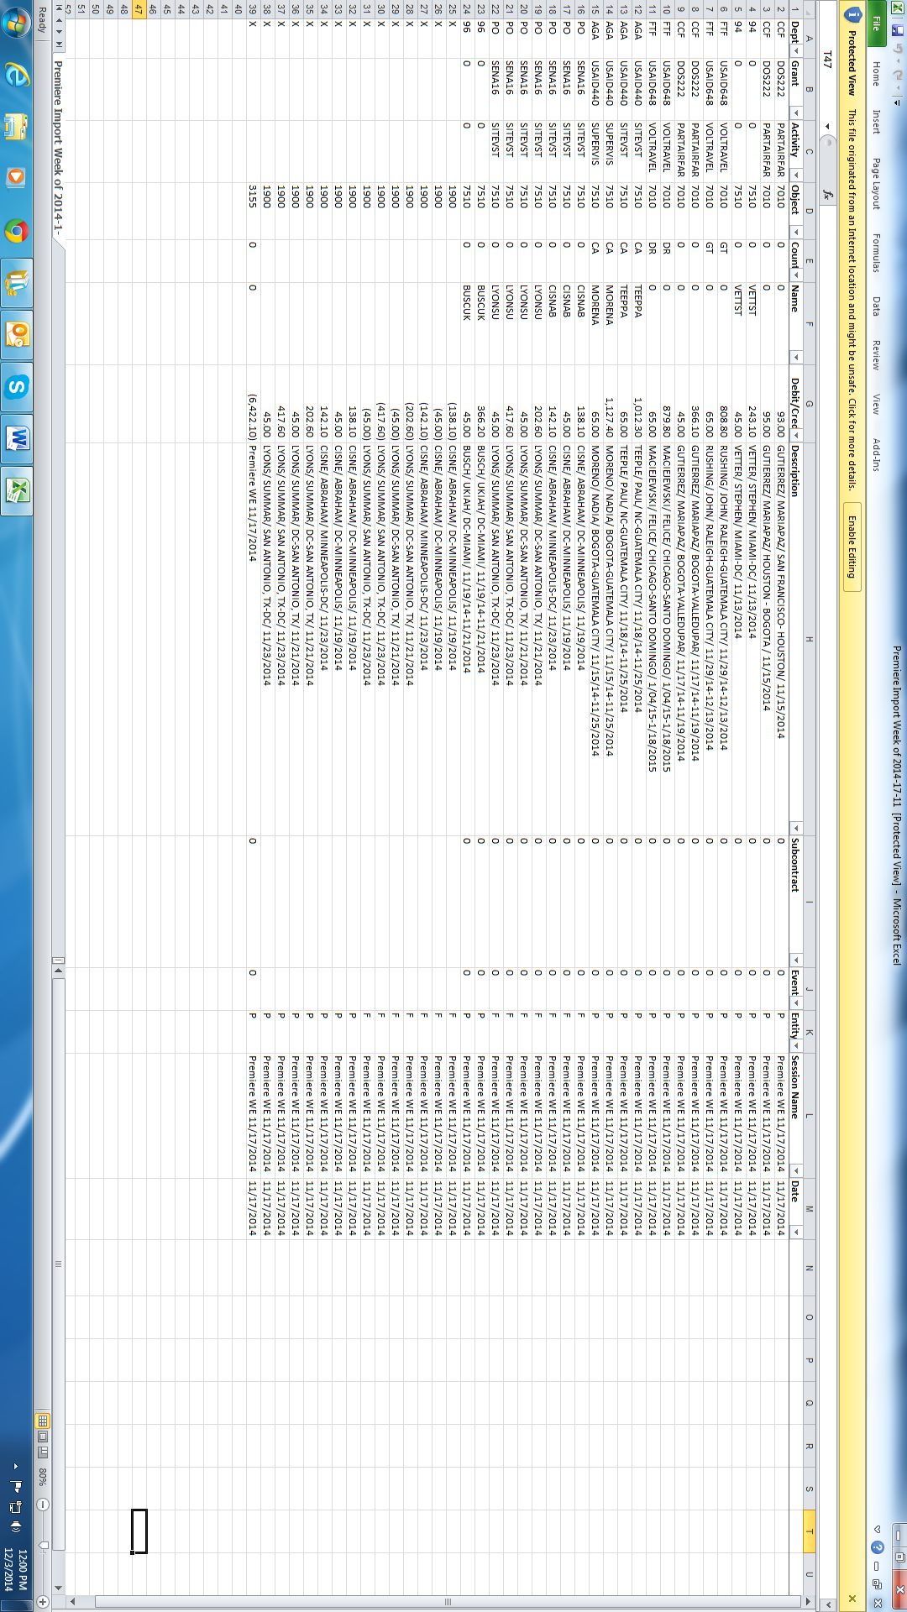
- Session name and date always the SAME (Altour Wk. ending mm/dd/yyyy) Post date: mm/dd/yyyy
- ***For all flights charged in prior year, but start date is in the following year they must be coded to 1350 (prepaid) with description Ex. USAID- MARTIN/ DANIELLE/ USA-COSTA RICA/ 1/16/16-1/21/26
- Save and the save as CSV version and upload to Sage Intacct

Reconciling Month Divvy Statement with Altour (Monthly)
- It is important to reconcile the Divvy card used by Altour Travel with what has been posted into Sage Intacct (using your weekly import spreadsheet is usually the easiest way to do this). There are always going to be discrepancies, extra fees, refunds that are not in the weekly Altour reports, but we need to make the adjustments in Sage Intacct.
- You can use the import template to import these adjustments just like you would with a regular Altour travel import.
- Make JV as necessary to clear up outstanding charges

Revenue Recognition

Purpose
- The purpose of this policy is to ensure that Partners is compliant with the standards and regulations for the recording of Revenue as set forth by the following to ensure consistent treatment of all revenue streams:
  - Generally Accepted Accounting Principles (GAAP),
  - Internal Revenue Service (IRS)
  - Financial Accounting Standards Board’(FASB, specifically FASB ASC 958-605, “Accounting for Contributions Received and Contributions Made”

Overview
- Revenue Definition
  - Generally, revenue is defined as money or other assets received by an organization for goods or services provided during a certain time period. It also includes donations, sales, exchange of assets; interest, dividends and any other increase in owner's equity and is calculated before any expenses are subtracted. Examples of PARTNERS revenue include: Contract Revenue, Donations, Fee for Service Revenue, Grant Revenue, Interest Income and Investment Income, Temporarily Restricted Revenue (time or donor) and Deferred (Unearned) Income.
- Recognition
  - PARTNERS recognizes all revenue based on the accrual method of accounting in accordance with GAAP, which requires that revenue should be recognized when it has been earned, regardless of the timing of the actual receipt of the cash. Revenue is considered earned when PARTNERS has substantially met its obligations according to the contract or award from the funder. Deposits (whether refundable or non-refundable), early payments and progress payments received ahead of the fulfillment by PARTNERS of the terms of the agreement are recorded as deferred income.
- Accruals and Cutoff
  - Revenue is recognized in the period in which it was earned regardless of the timing of PARTNERS’s invoicing or receipt of funds from the funder. At the end of each month, revenue that has been earned but not invoiced or received is accrued and recorded as revenue via a journal entry. The entry will debit Accounts Receivable and credit the specific revenue account for the funder.

Types of Revenues
- Dues and Membership Fees
  - PARTNERS collects dues or membership fees from its charter members. In return for membership fees, PARTNERS provides training or resources to participants such as universities, organizations and individuals. These membership fees are based on the following categories of membership: individual, student chapters, chapter, small organizations, and higher education institutions. Members do not receive any taxable benefits in return for their membership or dues.
- Donations from Individuals and Corporations
  - A donation and/or contribution is an unconditional transfer of cash, cash equivalent or other assets to an entity or a settlement or cancellation of its liabilities in a voluntary nonreciprocal transfer by entity acting other than as an owner. Other assets include securities, land, buildings, use of facilities or utilities, materials and supplies, intangible assets, services, and unconditional promises to give those items in the future. Some inflows of assets are not included in the definition of contributions:
    - Transfers that are exchange transactions, in which both parties receive goods or services of commensurate value.
    - Transfers in which the organization is acting as an agent, trustee, or intermediary for the donor (the organization has little or no discretion concerning the use of the assets transferred)
    - Tax exemptions, tax incentives, and tax abatements.
- Investment Income
  - PARTNERS Foundation has a number of investments which are in the Investment Fund. The investment funds are managed by investment advisors at Merrill Lynch. The Investment Funds are divided into two separate accounts, Endowment and Board Designated. The investment income is recognized as the income resulting from dividends, interest, and increases in market value after the deduction of investment fees.
- Interest Income
  - Interest income is the amount of interest that has been earned during a specific time period. The amount of interest may have been paid in cash, or it may have been accrued as having been earned but not yet paid. In the latter case, interest income should only be recorded if receipt of the cash is probable, and the amount of the payment to be received is identifiable. PARTNERS Interest income is earned from investments that pay interest, such as in a savings account or certificate of deposit.
- Grants and Awards Revenue
  - PARTNERS receives awards and grants from various donors including the Federal Government and private funders. Grants and awards are recorded as revenue in the year the notification is received from the donor. Time or Donor restricted contributions are released as the donor imposed conditions are met. Such pledges, awards and grants received are shown as Temporarily Restricted Net Assets on the Combined Statement of Activities and Changes in Net Assets.
- Pledges
  - Pledges are promises to donate money or services during a specific time period or when a specific condition(s) is met. Pledges may be considered either conditional or unconditional depending on the conditions specified by the donor. PARTNERS records promises to give as required by Generally Accepted Accounting Principles (GAAP) standards and recognizes revenue when the terms of the donation are met. Promises to give at a future date are discounted and recognized at their net present value.
- Exchange Transactions vs. Donations
  - Often it is difficult to distinguish between a contribution and an exchange transaction, the following factors are indicative of an exchange transaction:
    - Economic penalties if the terms of the agreement are not met
    - The payee specifies the time and place of delivery of any goods or services
    - The payment is calculated in a manner that provides a "profit margin" for the recipient
    - The payee receives a direct benefit from the payee (excluding any intrinsic benefit from helping the NFP)
    - The grant requires that the recipient provide the grantor with a specific service, facility or product rather than providing the benefit to the general public
- Fee for Service/Pass Through
  - PARTNERS receives funds under “Fee for services” contracts and pass-through agreements. Revenue under these contracts is recognized based on the work performed in correlation to the deliverables of the agreements. Additional funds received beyond the cost to perform the work are considered unrestricted income. Fees for service are recognized as a flat percentage of the total pass-through grants during the period in which they are distributed.

Revenue Recognition Regulations
- Rules and Regulations
  - The revenue recognition process shall follow the criteria and specific requirement ass set forth in:
    - 2 CFR 200.303 “Internal Controls” requires recipients of Federal funds to establish internal controls that should be in compliance with guidance in the “Internal Control Integrated Framework” issued by the Committee of Sponsoring Organizations of the Treadway Commission (COSO).
    - Financial Accounting Standards Board (FASB) ASC 958-605, Accounting for Contributions Received and Contributions Made.
    - Generally Accepted Accounting Procedures (GAAP)
- Reconciliation Process
  - Finance will perform a reconciliation of all awards and releases to the PARTNERS general ledger on quarterly basis. This quarterly reconciliation will result in a documented review and approval process. The document will require two signatures, one from a member of the respective program team and the other from an F&A member. These documents will be saved and recorded in the finance office in accordance with PARTNERS’s Record Retention Policy. Per 2 CFR 200.302(b)(7), Partners must compare actual expenditures against budgeted amounts for each Federal award at least quarterly. Where actual expenditures deviate from budget by 10% or more in any budget line, or where cumulative expenditures are projected to exceed the award period, the CFO/Controller must notify the relevant program manager and, where required by the award terms, the Federal awarding agency. No costs may be charged to a Federal award outside the approved period of performance, per 2 CFR 200.309. The Senior Accountant is responsible for flagging any charges dated outside the period of performance to the CFO/Controller before posting.
- Responsibilities
  - Program Managers:
    - Provide hard copy of Grants and Awards with Approved Signatures which will then be saved as a formal signed evidence.
    - Review and verify the contents and accuracy of grants & awards from the schedules issued by the F&A team on a periodic basis (at a minimum quarterly).
  - F&A Team
    - Update the official revenue recognition policy as needed, at a minimum of once per year.
    - Maintain and keep evidence of all PARTNERS’s income streams, including conditional and unconditional assistance awards, contract income (including pass-through funding) as per PARTNERS’s record retention policy.

Grants Management Model

Overview
- Most of the awards PARTNERS receives are cost reimbursable cooperative agreements. PARTNERS uses the following model to record receivables, deferred, costs and revenues. A receivable is created when an award is obligated with an offset to deferred revenue. The deferred revenue is considered a temporary restricted net asset. Once costs are incurred and charged to the award. Monthly indirect costs are calculated and added to the award cost. Then revenue is created to match the expenses (unless there are donor imposed restrictions that limit the revenue). Revenue is created by releasing (debiting) the deferred revenue account and crediting grant revenue.

Model and Illustrative of Grants Model
- Below is an example of the process for the grants model with T-account demonstrations.
- Journal entries for new grants model:
  - Received a grant (obligation of award):
    - Grant receivable account (debit)
      - Temporary restricted - Deferred (credit)
  - Cash Receipt (Draw-down) funds:
    - Cash (debit)
      - Grant receivable account (credit)
  - Record an grant disbursements (expenses):
    - Expense (debit)
      - Cash (credit)
  - Record expense allocation (indirect costs):
    - IDC grant expense (debit)
      - 95ID (credit)
  - Revenue recognition:
    - Temporary restricted - Deferred (debit)
      - Grant Revenue (credit)
- The flowing flowchart shows the flow of funds and journal entries from the obligation of awards, through cash receipts, cash disbursements, expense allocation and revenue recognition.

Monthly Tasks

Upload Field Reports
- The Senior Accountant receives field reports and forwards them to the CFO/Controller for review and approval. The CFO/Controller provides approval before posting the reports in Sage Intacct.
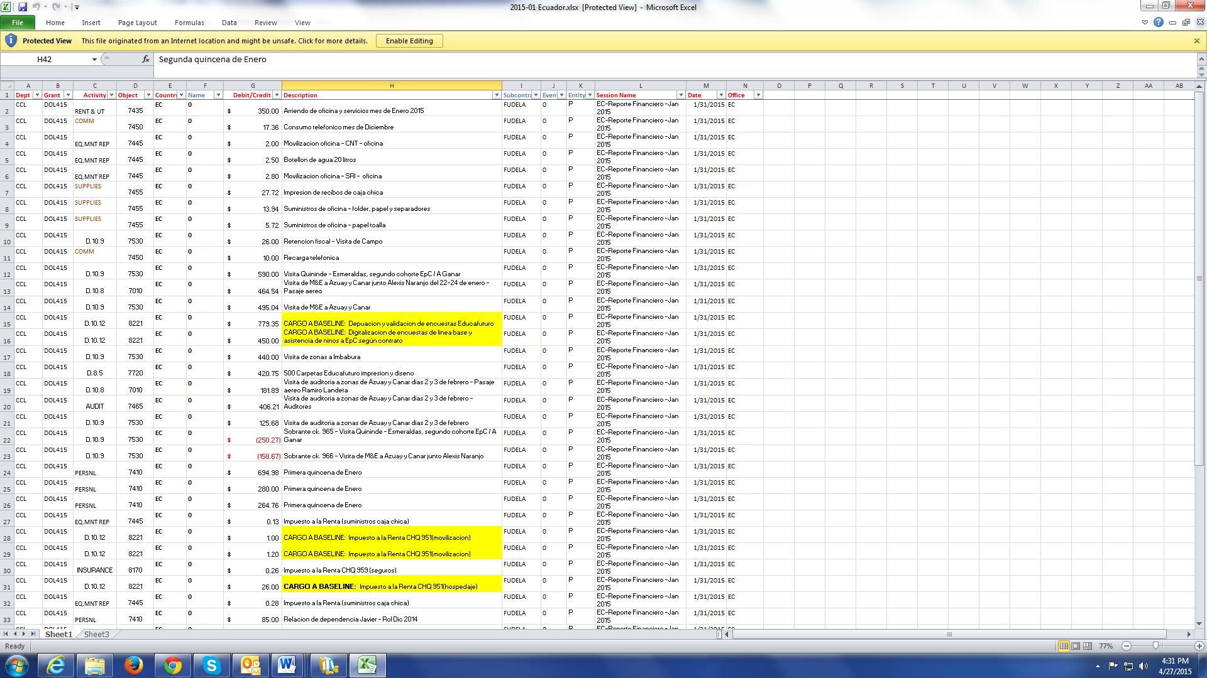
- Copy and paste new field report information in the pre-existing form:

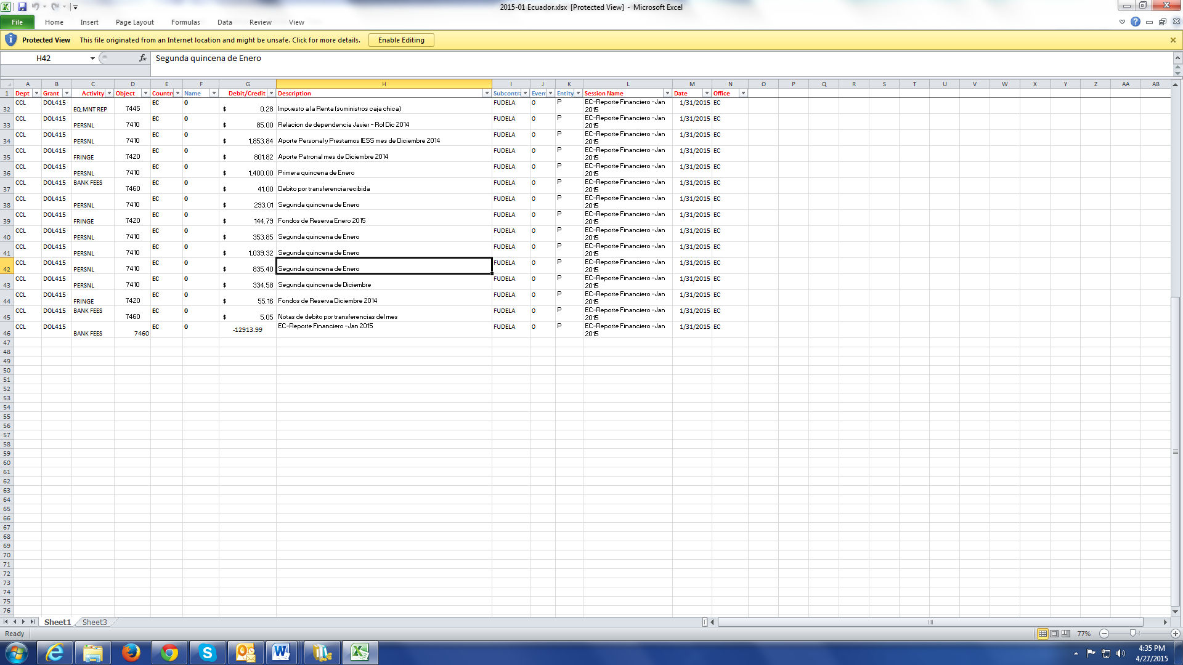
- Note: for the upload into Sage Intacct to work properly the last line to clear the 1203 account must be uploaded as a copy of the previous line above (since in excel all fields must be filled in). Example:
- Save file as a CSV format and upload into Sage Intacct.
- Once uploaded go into and change the last line of the upload to clear the 1203 account.
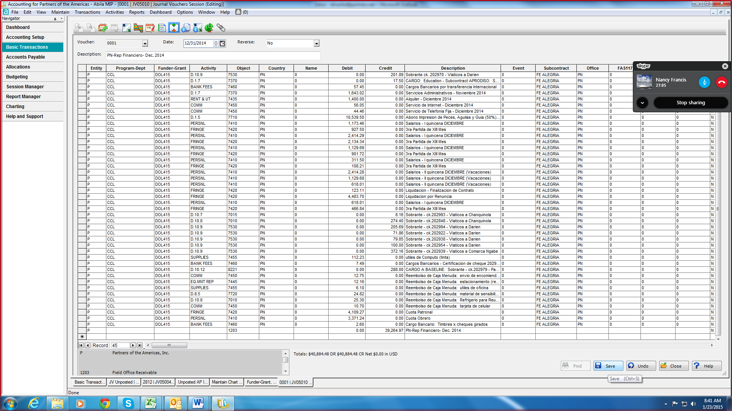
- Print JV for approval.
- Then post and file in correct binder.

Post Cash Receipts
- Delegation of Authority: The Senior Accountant enters all Cash Receipt sessions in Sage Intacct. The CFO/Controller reviews, approves, and posts all Cash Receipt sessions. The bank statement will be available on the Bank of America website a few days after the prior month ends. Print a copy and mark all payments that need to be manually entered into Sage Intacct:
- Go over deposits and assign number: date- a, b, c –depending on the number of transaction in that date
  - Example: deposit made 11/15/16 would be 111516-A
  - Second deposit made on 11/15/16 would be 111516-B, etc.
- Write assigned number on the cash receipts
- Then gather all the documentation for each cash receipts. (Keep in mind this should be done on an ongoing basis so you simply sort through the documentation). Sufficient documentation for cash receipts are: invoices, award letters/contracts (for non-government payments), draw-down confirmation (provided by the CFO/Controller to the Senior Accountant), etc., as well as the deposit confirmation printout from Bank of America. Per 2 CFR 200.305(b), Federal award payments must be supported by adequate documentation of the draw-down and deposited funds.
Bank Deposits:
- Create new CR
  - Session ID: Bank Deposit 11/10/16
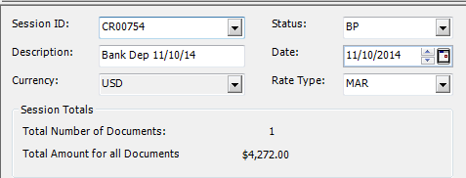
  - Date: 11/10/16 – Must match

- Create new Document number then leave description as Bank Deposit 11/10/16
  - Deposit Number: is the assigned number- 111016-A
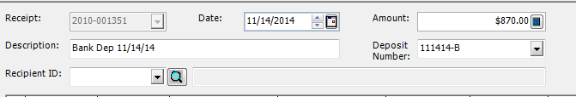

- Enter the check and cash to where they should be credited
  - Description: check name and # and Bank Deposit 11/10/16 Ex. Global Giving Ck# 212145- Bank Deposit 11/10/16
  - ***Checks and cash should all be entered separately, even if all going to credit the same place***
  - DACOR can be entered as one lump sum
- Write CR number at the bottom of the deposit slip
- Print CR for approval and staple to deposit slips
LOC Draws:
- Create new CR
  - Session ID: LOC DRAW 11/10/16
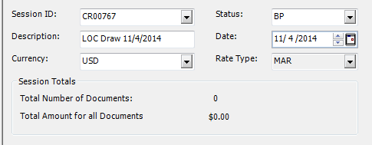
  - Date: 11/10/16 – Must match

- Create new Document number then leave description as LOC Draw 11/10/16
  - Deposit Number: is the assigned number- 111016-A
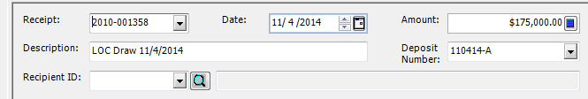

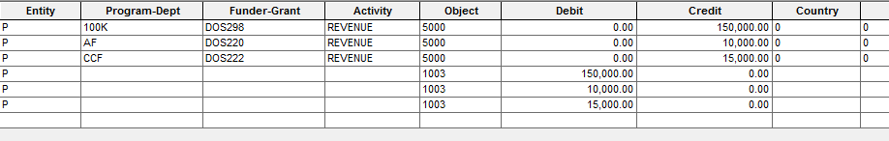
- Enter the LOC to where they should be credited
- ***Each LOC should be separated, unless funds are lump summed together***
- Write CR number at the bottom of the deposit slip
- Print CR for approval and staple to deposit slips
Merch SVC DES:
- Same as LOC Draw except coding below:
- Each invoice and payment received must be entered separately with clear descriptions
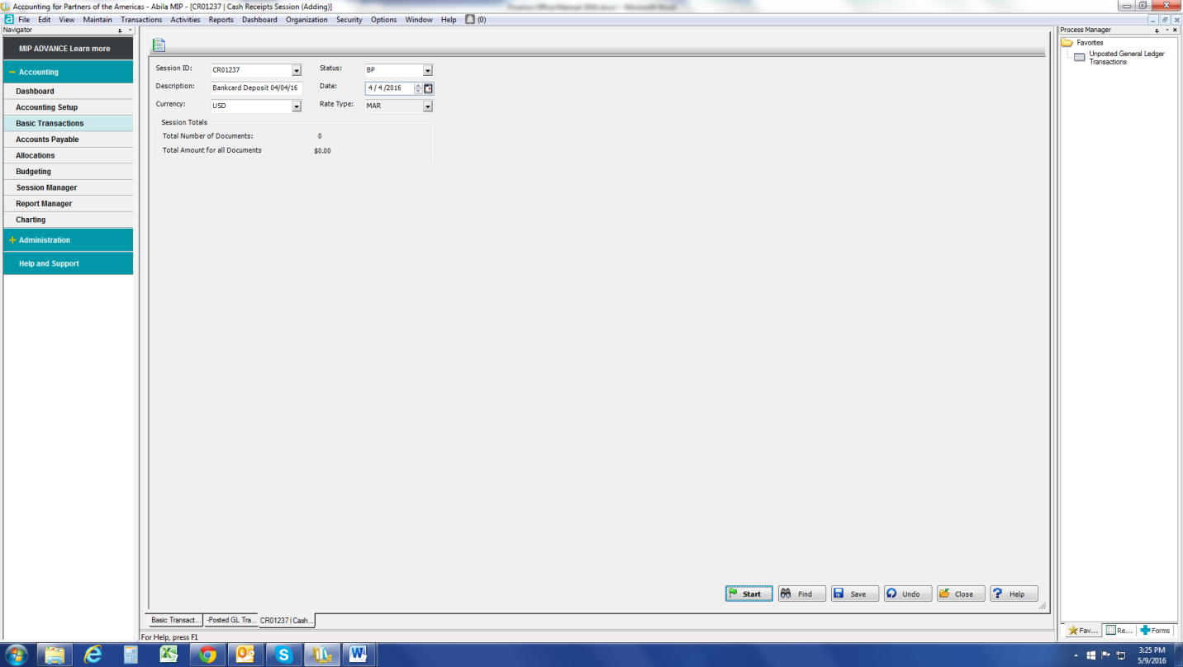

Return Wire/ACHs:
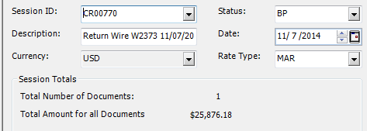
• Same as LOC Draw except coding below and bank fees:

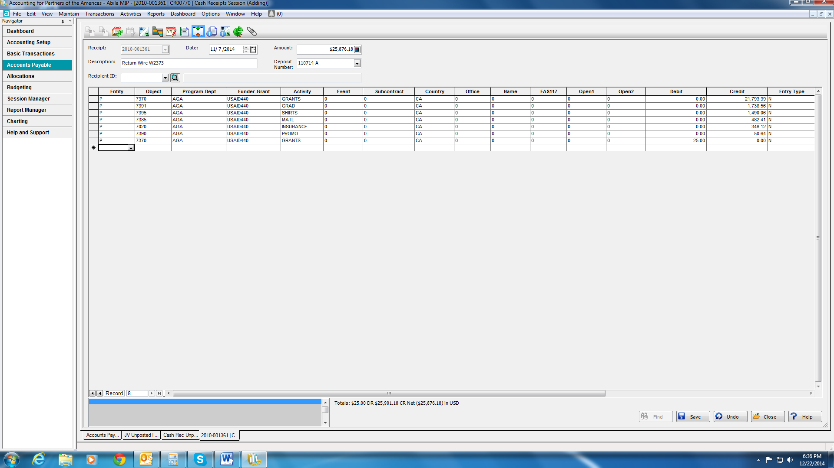
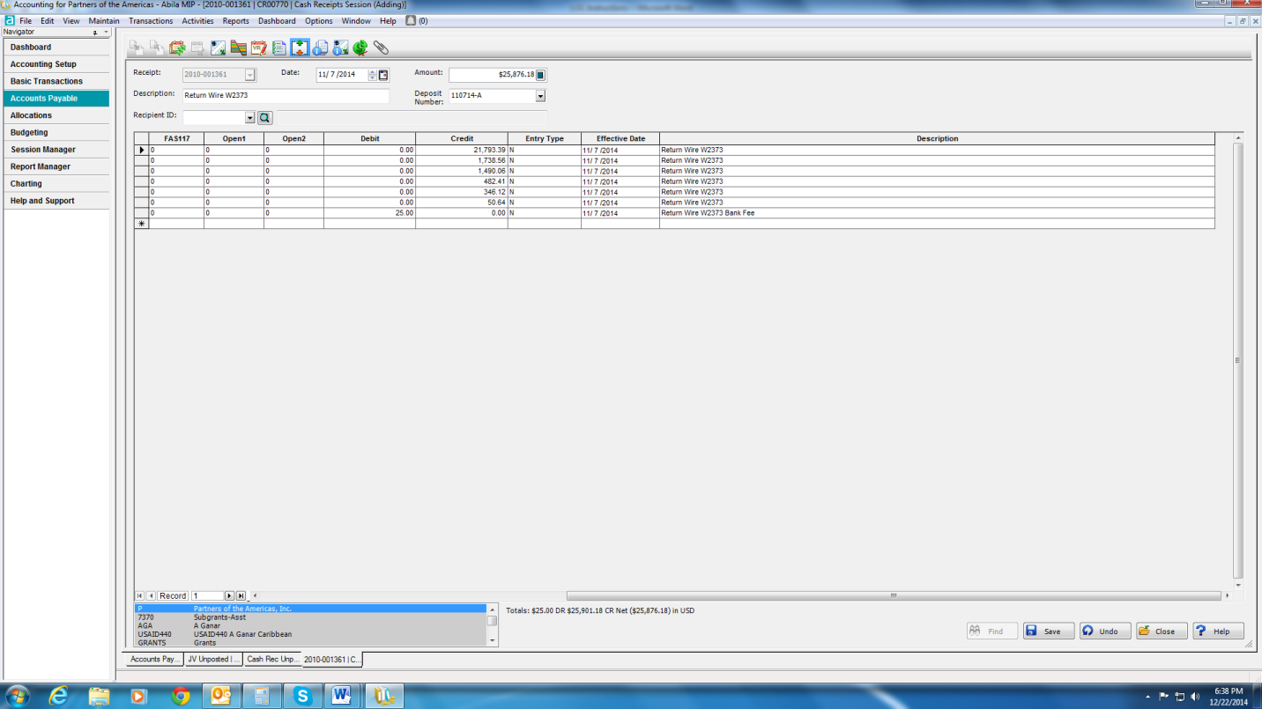

Amazon Smile:
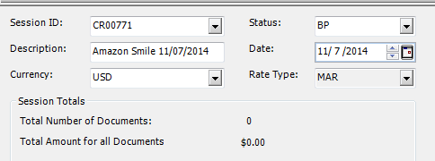
- Same as LOC Draw except coding below:

Post Bank Adjustments
- Delegation of Authority: The Senior Accountant enters all bank adjustment Journal Vouchers in Sage Intacct. The CFO/Controller reviews, approves, and posts all bank adjustment entries. The bank statement will be available on the Bank of America website a few days after the prior month ends. Print a copy and mark all payments that need to be manually entered into Sage Intacct:
  - Line of Credit Autoborrow Debits and Credits
  - FSA debit card transactions and other payments
  - Credit card merchant fees, bank fees and bank interest
  - Washington Metro (Smart Benefits) payment
- Go over deposits and assign number: date- a, b, c –depending on the number of transaction in that date
  - Example: deposit made 11/15/16 would be 111516-A
  - Second deposit made on 11/15/16 would be 111516-B, etc.
- Create new JV session:
  - Description: Dec Bank Adjustments DM 12/31/16
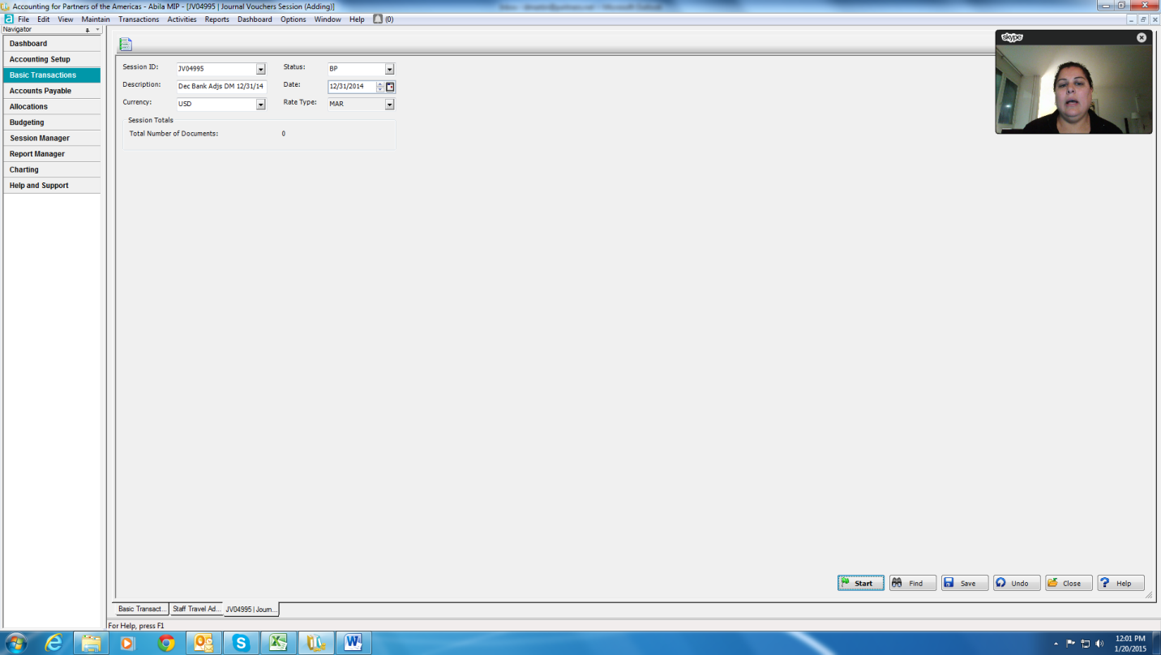
  - Date: Last date of the month

- Enter each transaction in Sage Intacct as its own document (otherwise they will not show up as individual payments for the bank reconciliation).
- The following have previous entries to copy, so all you need to do is correct the date and amount and copy:
  - Account Analysis Fee (bank services fee)
  - Bank Card Fees (Visa/MasterCard and Divvy merchant fees)
  - Processing Fees (Affinipay merchant fees)
  - Commercial Loans Debit (bank interest)
  - Credit Autoborrow / Debit Autoborrow
  - GBS FSA Payment (for any GBS/FSD manual payments)
  - Wash Metro Trans Benefit (SmartBenefits payment)
- Create new JV session and Copy Posted Transaction



- Find the Session ID you are trying to copy (find previous bank adjustments JV from the year)

- Copy the document number for whatever item your entering (look at description to make sure it is for the same item)
- Copy to Document: Enter assigned coding Ex. 120416-D
- Document Date: Must be date money hit our bank account, never use original document date
- Effective Date: Must be date money hit our bank account, never use original effective date
- Document Description: Update as necessary to changes dates, etc.
- Click “Use Document Description for Line Items”
- Update the amount
- Click save
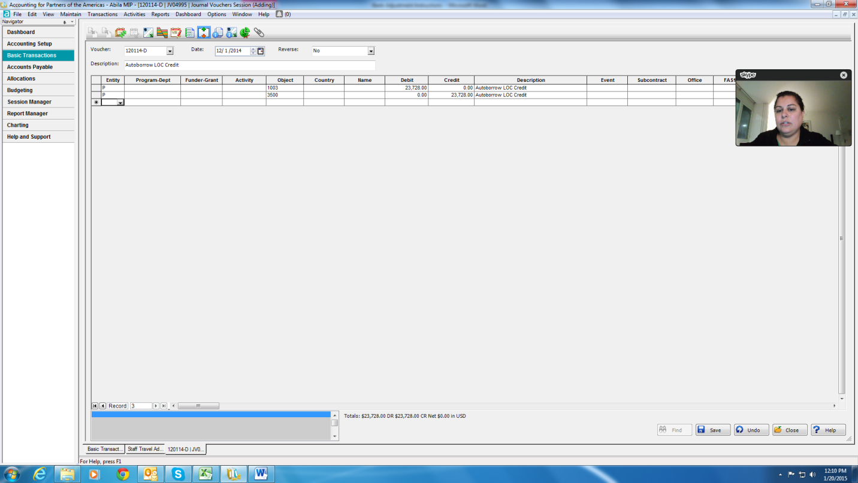

- Write JV number on the actual bank statement next to the credit or debit
- Continue entering all Auto Borrow Debits and Credits, Bank Card Fees, and Washington Metro Transit, etc.
- For items entered in the on the Dec. Disbursement JV – write number next to those items
- Enter all the Cash Receipts and LOC and write CDs and CRs on bank statement
- Cross check all wire/ACHs released with Sage Intacct:
- First highlight the wire/ACH numbers and amounts on the bank statement
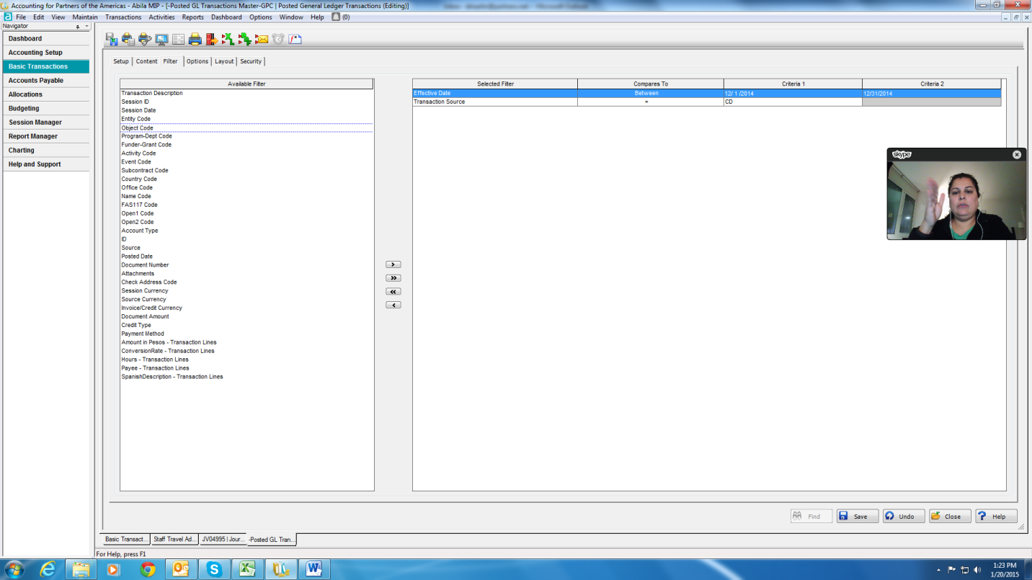
- Then run search on posted CDs in Sage Intacct
- Match wire/ACHs on bank statement to Sage Intacct report, and check off next to it and write the CD that it was entered in on the bank statement

Post Cash Disbursements
- Delegation of Authority: The Senior Accountant enters all Cash Disbursement sessions in Sage Intacct. The CFO/Controller reviews, approves, and posts all Cash Disbursement sessions. Disbursements are recorded in the month they were paid, regardless of the statement date include: Visa, Divvy, and Principal
- Basic Transaction> Cash Disbursements click “+” to create new session
- Start new CD session:
  - Description: Month Year Cash Disbursements
  - Date: End of month
  - Cash Acct: 1003
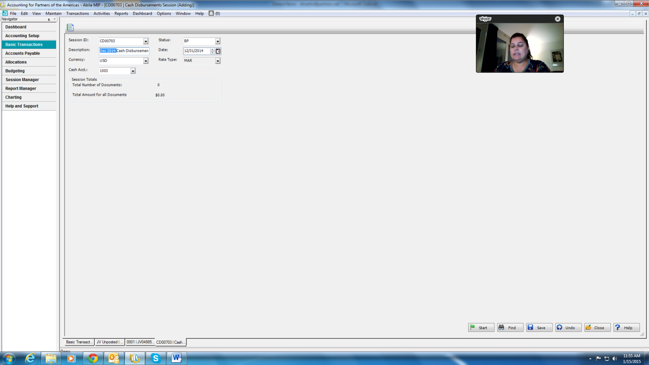

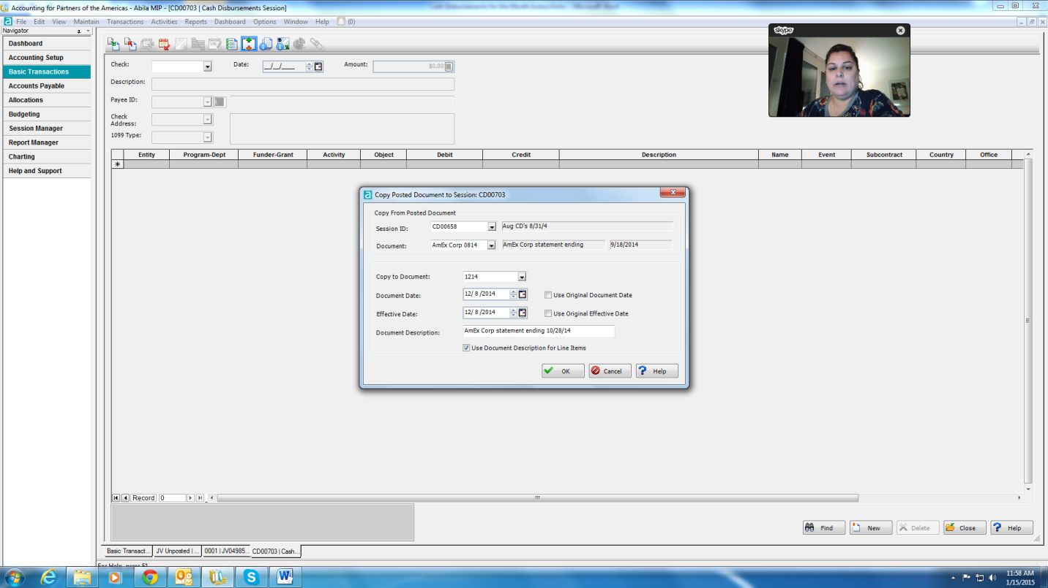
For Divvy:
- Start session and Click on
- The Copy to Posted document screen appears below:
  - Session ID: CD from previous or CD00697
  - Document: Divvy Corp (pick one)
  - Document Date: Date paid from Bank
  - Effective Date: Date paid from Bank
  - Document Description: Divvy Corp Statement ending 10/28/16 (Current Date)
  - Check the box for: Use document description for line items and click okay
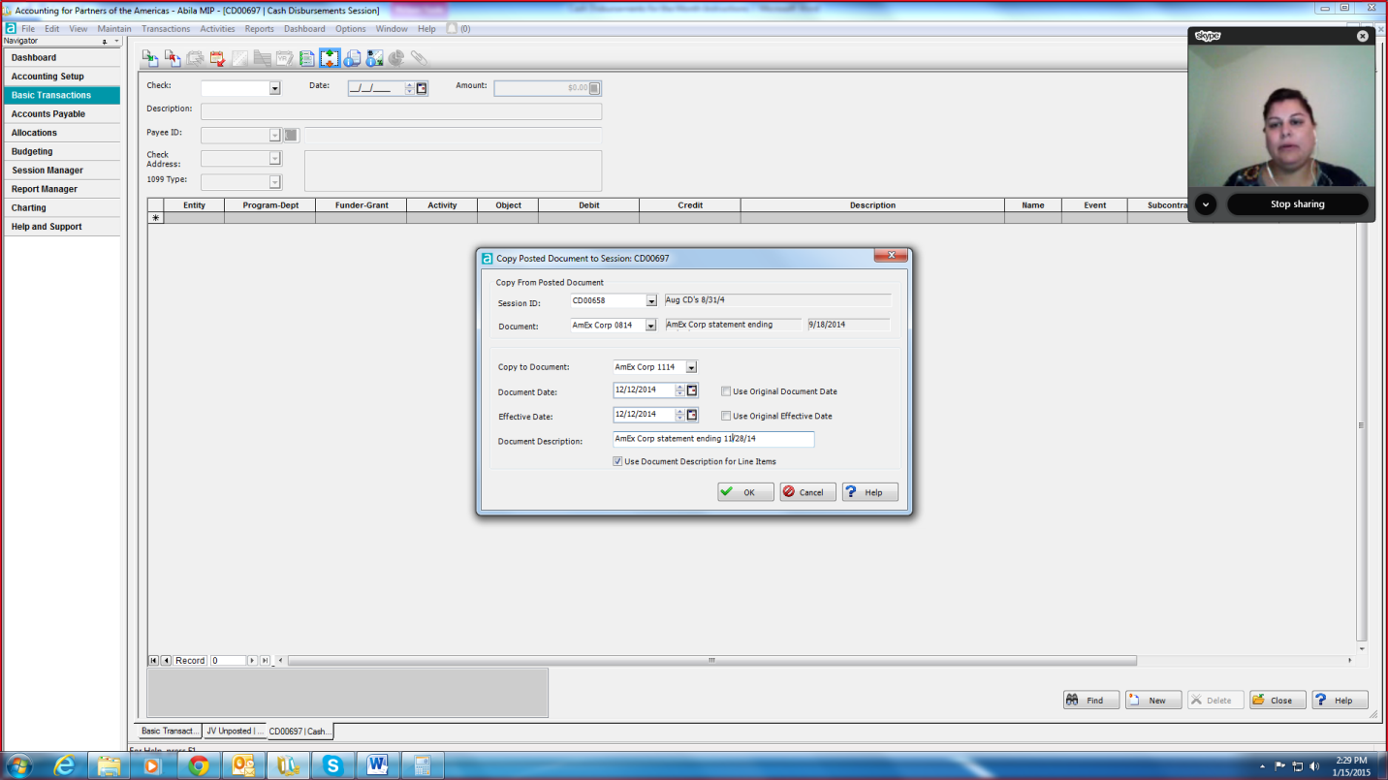
  - Copy to Document: Divvy Corp 1016 (monthyear)

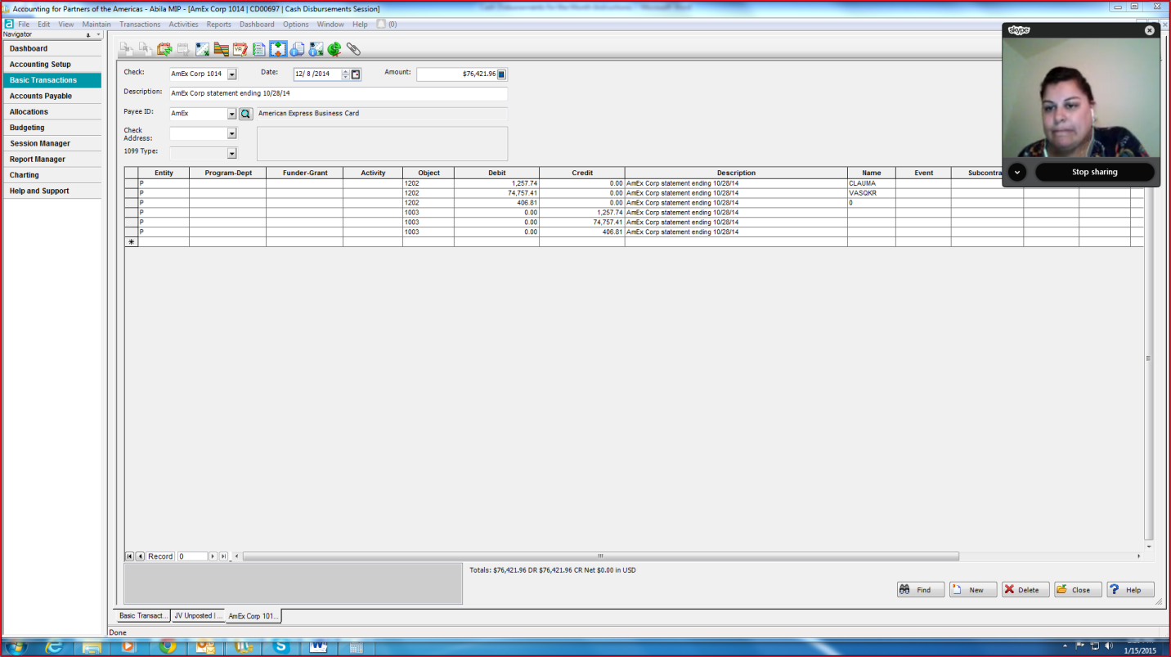
- Click Ok and edit the amounts as necessary corresponding to the statement and name codes.
- Note that all items should debit 1202 with a name code of card holder and credit 1003.

For Visa:
- Start session and Click on
- The Copy to Posted document screen appears below:
  - Session ID: CD from previous or CD00697
  - Document: Visa Corp (pick one)
  - Document Date: Date paid from Bank
  - Effective Date: Date paid from Bank
  - Document Description: Visa Corp Statement ending 10/28/16 (Current Date)
  - Check the box for: Use document description for line items and click okay
  - Copy to Document: Visa Corp 1016 (monthyear)
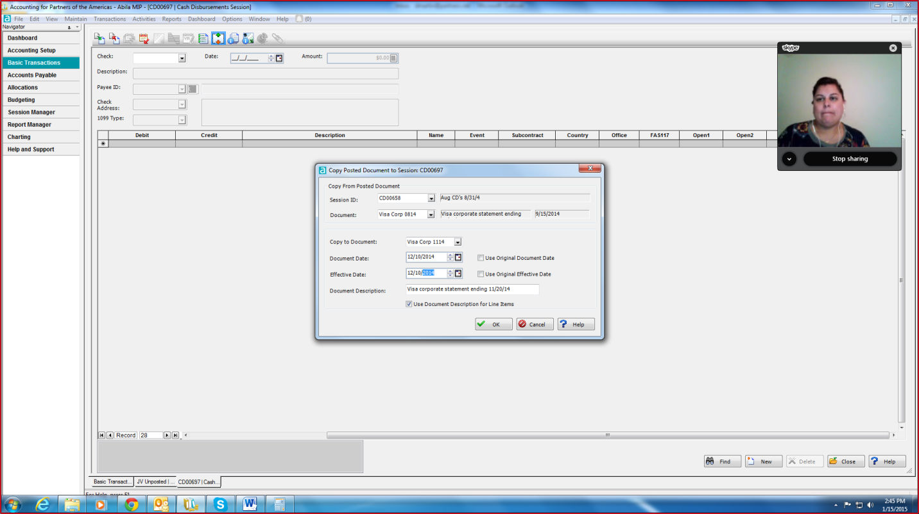

- Click Ok and edit the amounts as necessary corresponding to the statement and name codes.
- Note that all items should debit 1202 with a name code of card holder and credit 1003.

For Principal:
- Start session and Click on
- The Copy to Posted document screen appears below:
  - Session ID: CD from previous or CD00697
  - Document: Principal (pick one)
  - Document Date: Date paid from Bank
  - Effective Date: Date paid from Bank
  - Document Description: Tax Sheltered Annuity for Pay Date 03/31/16 (Pay Date that the Principal payment covers)
  - Check the box for: Use document description for line items and click okay
  - Copy to Document: Principal 0316 (monthyear)
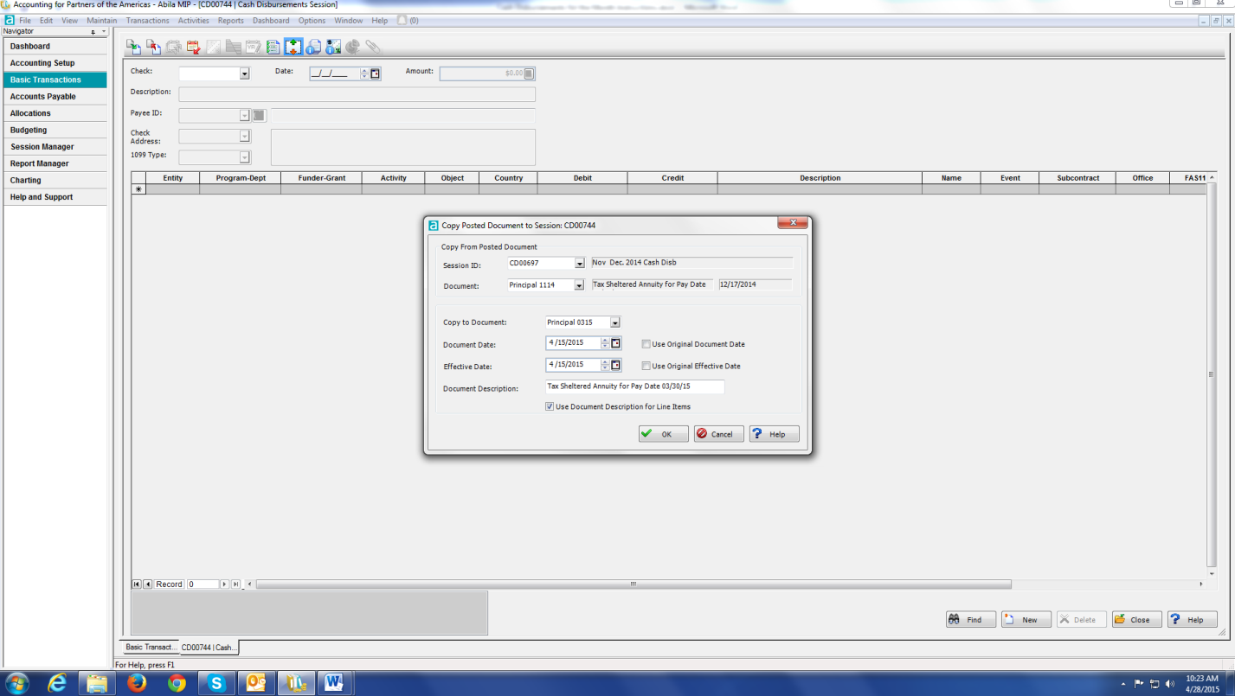
  - Note that there are usually 2-3 principal payments per month so next one would be Principal 0316A, Principal 0316B, etc.

- Click Ok and edit the amounts as necessary corresponding to the statement payout.
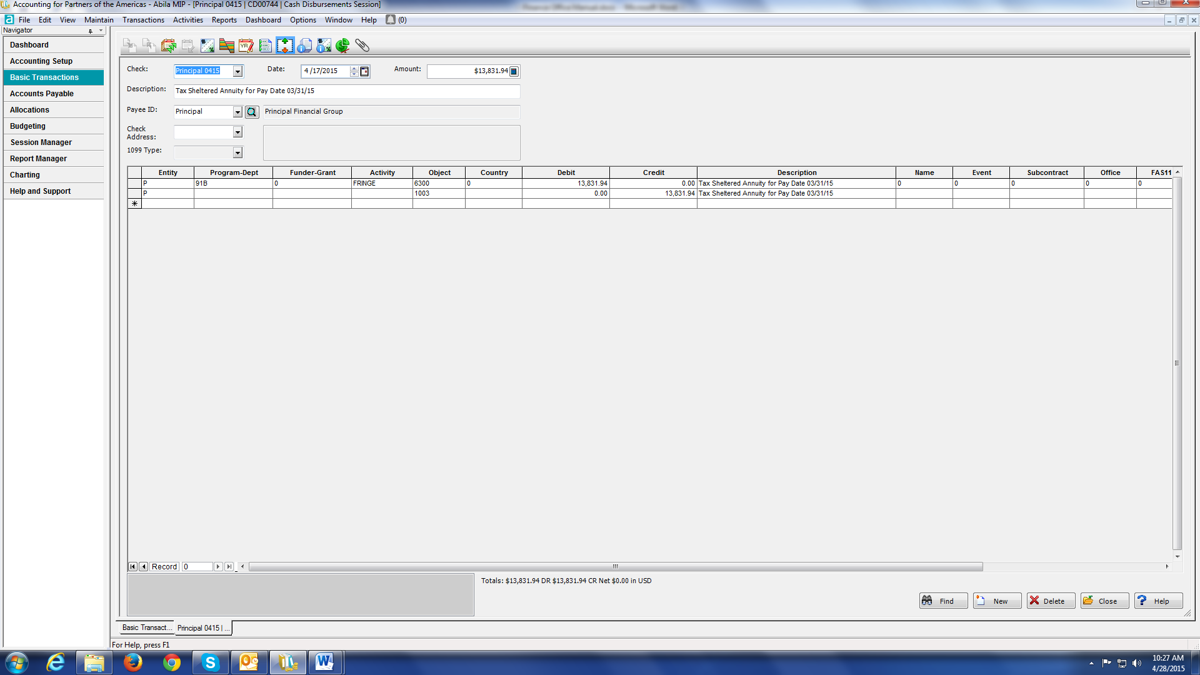
- Note that all items should debit 91B-FRINGE-6300 and credit 1003.

Prepare Divvy Expense Reports
- Just like other staff members you must prepare expense reports for any credit cards issued in your name, except for the Altour Travel card (as described above).
- There is an Divvy card in my name marked AP that can be used by anyone to pay for bills, large purchases, etc. Make sure you get the receipts and coding information so you can create an expense report later.

Monitor Staff Expense Report Submission
- Create a report in Sage Intacct totaled by person (Name Code). Use this report to see which staff members have outstanding advances and credit card statements.
- When the new monthly statement for both Visa and DIVVY is received, it is important to update the Expense Report Tracking

- Under each individuals name tab write it the amount due for that month. If no charges were made black out the box:

- Once a staff member submits a statement and it is audited and processed. The comment section should be updated to state: Processed. The JV number should be entered and the box highlight to green.
- Once a staff member has missed the submission deadline without contacting F&A to notify the team of the situation a delinquency email is sent. Copy email to, Employee Manager, Sergey, and employee. Staff members can speak with F&A and request an extension and a note on the spreadsheet will be made.

Quarterly and Semi-Annual Tasks

Categorizing Supplies, Equipment, & Other Capital Expenditures
- Definitions:
  - Equipment means tangible personal property (including information technology systems) having a useful life of more than one year and a per-unit acquisition cost which equals or exceeds USD $10,000.
  - Supplies means all tangible personal property other than those described in equipment (above). A computing device is a supply if the acquisition cost is less than USD $10,000, regardless of the length of its useful life.
  - Capital expenditures means expenditures to acquire capital assets or expenditures to make additions, improvements, modifications, replacements, rearrangements, reinstallations, renovations, or alterations to capital assets that materially increase their value or useful life.
    - Capital expenditures for special purpose equipment are allowable as direct costs, provided that items with a unit cost of $10,000 or more have the prior written approval of the Federal awarding agency or pass-through entity.
    - Capital expenditures for improvements to land, buildings, or equipment which materially increase their value or useful life are unallowable as a direct cost except with the prior written approval of the Federal awarding agency, or pass-through entity.
    - Capital expenditures will be charged in the period in which the expenditure is incurred.
  - Capital assets means tangible or intangible assets used in operations having a useful life of more than one year which are capitalized in accordance with GAAP. Capital assets include: (a) Land, buildings (facilities), equipment, and intellectual property (including software) whether acquired by purchase, construction, manufacture, lease-purchase, exchange, or through capital leases; and (b) Additions, improvements, modifications, replacements, rearrangements, reinstallations, renovations or alterations to capital assets that materially increase their value or useful life (not ordinary repairs and maintenance).
  - Acquisition cost means the cost of the asset including the cost to ready the asset for its intended use. Acquisition cost for equipment, for example, means the net invoice price of the equipment, including the cost of any modifications, attachments, accessories, or auxiliary apparatus necessary to make it usable for the purpose for which it is acquired. Acquisition costs for software includes those development costs capitalized in accordance with generally accepted accounting principles (GAAP). Ancillary charges, such as taxes, duty, protective in transit insurance, freight, and installation may be included in the acquisition cost.

Inventory Control Recording and Monitoring
- A physical inventory of the property must be taken and the results reconciled with the inventory master list and records at least once every year, typically done at the end of each year.
  - All purchased equipment and other capital expenditures over US $10,000 should be listed.
- Each program unit with a country office shall maintain an accurate “Master Equipment Listing” that at minimum has the following information:
  - A description of the equipment
  - Acquisition value
  - Acquisition date.
  - A model number or some other kind of tracking number
  - Location of the equipment
- An example of a Master Equipment Listing is below:
- The “Master Equipment Listing” is held in the country office and should only include:
  - Tangible non-expendable property that was purchased with program funds
  - Useful life of more than one year
  - Acquisition value that adheres to limits in the local laws. In the absence of specific citation in the local laws, the acquisition value should only include items above $10,000 per item. However, the local laws take precedence and set the limits.

- All purchased equipment over US $10,000 should be extracted from the “Master Equipment Listing” and sent to Headquarters and labeled as “Equipment Listing for Country Office” for reconciliation purposes. Although equipment may be valued at less than US $10,000 and on the “Master Equipment Listing”, they should not be included in the “Equipment Listing for Country Office” sent to Headquarters.
- When booking in country inventory listings in Sage Intacct coding must be as follows:
  - $10,000+ - In-Country Equipment – 7440
  - Less than $10,000 – In-Country Supplies – 7455

- Semi-annually the Finance Officer will review the 7440 account for each country and make sure the equipment listed matches the Equipment Listing for Country Office received from the field.
- The Finance Office will then use this information when calculating its annual depreciation entry.

In-Kind Contribution Policy & Recording

Purpose
- The purpose of this policy is to ensure that Partners is compliant with the standards and regulations for the recording of In-Kind Contributions as set forth by Generally Accepted Accounting Principles (GAAP), the Internal Revenue Service (IRS) and the Financial Accounting Standards Board’(FASB).

Scope
- This policy applies to contributions of all in-kind services and assets, including promises to give. It does not apply to transfers of assets that are in substance purchases of goods or services, exchange transactions in which each party receives and sacrifices commensurate value. However, if an entity voluntarily transfers assets to another or performs services for another in exchange for assets of substantially lower value and no unstated rights or privileges are involved, the contribution inherent in that transaction is within the scope of this Policy.
- Furthermore, this Policy does not apply to transfers of assets in which the reporting entity acts as an agent, trustee, or intermediary, rather than as a donor or donee. It also does not apply to tax exemptions, tax incentives, or tax abatements, or to transfers of assets from governmental units to business enterprises.

Definitions
- The following are the definitions for key terms discussed throughout the policy.
- Contributions
  - A contribution is an unconditional transfer of cash or other assets to an entity or a settlement or cancellation of its liabilities in a voluntary nonreciprocal transfer by another entity acting other than as an owner. Other assets include securities, land, buildings, use of facilities or utilities, materials and supplies, intangible assets, services, and unconditional promises to give those items in the future. Some inflows of assets are not included in the definition of contributions:
    - Transfers that are exchange transactions, in which both parties receive goods or services of commensurate value.
    - Transfers in which the organization is acting as an agent, trustee, or intermediary for the donor (the organization has little or no discretion concerning the use of the assets transferred)
    - Tax exemptions, tax incentives, and tax abatements
- Promises to Give
  - A promise to give is a written or oral agreement to contribute services or other assets to another entity; however, to be recognized in financial statements there must be sufficient evidence in the form of verifiable documentation that a promise was made and received. A communication that does not indicate clearly whether it is a promise is considered an unconditional promise to give if it indicates an unconditional intention to give that is legally enforceable.
- Exchange Transactions
  - Exchange transactions are reciprocal transfers in which each party receives and sacrifices something of approximately equal value. Partners must give up assets, rights or privileges approximately equal to the value of the assets, rights, or privileges received. Value should not be assessed from both Partners and resource provider’s point of view and vice versa.
- Hybrid Transactions
  - A hybrid transaction may also exist where the gift is part contribution and part exchange. An example would be a $500 per plate fundraising dinner where the value of the dinner (the exchange part) is $100 and the remaining $400 is considered contribution.
- Donor Restrictions
  - A donor-imposed condition on a transfer of assets or a promise to give specifies a future and uncertain event whose occurrence or failure to occur gives the promisor a right of return of the assets transferred or releases the promisor from its obligation to transfer assets promised. In contrast, a donor-imposed restriction limits the use of contributed assets; it specifies a use that is more specific than broad limits resulting from the nature of the organization, the environment in which it operates, and the purposes specified in its articles of incorporation or bylaws or comparable documents for an unincorporated association.
- In-Kind Contributions
  - In-kind contributions are the combination of both contributed assists and contributed services. In-kind contributions can be inventory, advertising and marketing media, donated items sold for fund-raising purposes, and contributions of long-lived assets. In-kind contributions can be both tangible and intangible personal property. For example this can includes tangible in-kind gifts such as furniture, equipment, etc. and intangible gifts of professional services that meet all the criteria of FASB ASC 958-605-258-16.
- Contributed Assets
  - Contributed assets are noncash assets that are donated to an organization such as property, food or supplies.
- Contributed Services
  - The receipt of services (not cash) from another entity or individual where such services benefits operations and Partners is under no obligation to pay for the services.
- Affiliate
  - A party that, directly or indirectly through one or more intermediaries, controls, is controlled by, or is under common control with an entity.
- Agency Relationship
  - This type of relationship arises when a donor and an organization or two organizations consent that one shall act for the benefit, and under the direction of the other.
- Value and Valuation
  - Value is the monetary worth of an in-kind contribution at a specific time and valuation is the act of determining that monetary value.

Contributed Services – Inclusions and Exclusion
- Partners receives a variety of volunteer time, whether it is for direct service in its programs, consultants, vendors, or board involvement. In accordance with GAAP, IRS, and FASB the value of contributed services must be recognized if the service either
- Creates or enhances assets that are not financial in nature (e.g. buildings, materials, supplies, etc.), or
- Requires specialized skills, are provided by individuals with those skills, and would typically need to be purchased if the services had not been donated. Common types of contributed services include architects, teachers, lawyers, accountants, bankers, investment advisors, doctors, construction services and property maintenance.
- Board Contributed Services
  - Contributed services of Board members are often not allowed to be considered in-kind contributed services, since Board members are expected to utilize their specialized skills in serving Partners as part of the regular roles and responsibilities of a Board member. In the event that a Board member contributes a service that they are specialized in and is deemed outside the normal roles and responsibilities of a Board member, this can then be considered a contribution.
- Contributed Personnel Services from Affiliates
  - In accordance with the FASB Accounting Standards Update (ASU) 2013-06, “Not-for-Profit Entities: Services Received form Personnel of an Affiliate”, any contributed personnel services Partners receives from any affiliate that directly benefits Partners and for which the affiliate does not charge Partners is consider contributed personnel services from affiliates. Charging Partners means requiring a payment from Partners, at least for the approximate amount of the direct personnel costs (for example, compensation and any payroll-related fringe benefits) incurred by the affiliate in providing a service to Partners or the approximate fair value of that service.
  - All personnel services received from an affiliate that directly benefit Partners (that is, are similar to personnel directly engaged by Partners), are considered contributed services. For example, that would include services performed by personnel of an affiliate for and under the direction of Partners and shared services. Shared services generally refers to services provided by a centralized function of one or more individuals within the affiliate group that Partners would otherwise typically need to purchase or have donated, if not provided by those personnel. The most common types of affiliate relationships Partners holds includes, but are not limited to, national or international organizations with local chapters, religious schools, corporate or supporting foundations, etc.

Contributed Assets – Inclusion and Exclusions
- Contributed assets are noncash assets that are donated to an organization such as property, food or supplies. Other assets include but are not limited to securities, land, buildings, use of facilities or utilities, materials and supplies, intangible assets, services, and unconditional promises to give those items in the future. Contributed assets received shall be recognized as revenues or gains in the period received and as assets, decreases of liabilities, or expenses depending on the form of the benefits received. Contributed assets shall be measured at their fair values in accordance with GAAP, IRS, and FASB.
- Non-Standard Contributed Assets
  - These items are defined by the IRS as the "contribution of an item that is not reasonably expected to be used to satisfy or further the organization's exempt purpose and for which (a) there is no ready market to liquidate the contribution to convert it to cash and (b) the value of the item is difficult to ascertain or speculative." These could be certain types of gifts, especially in-kind contributions (outdated computers, for instance) that can't easily use or dispose of safely.
- Donor or Legally Restricted Contributed Assets
  - Partners may also receive in-kind contributions with restrictions on the use of donated assets. It is important to distinguish between legal restrictions and donor restrictions placed on Partners. Donor restrictions should not have an effect on the valuation of an in-kind contribution. However, legal restrictions may affect the determination of the principal market, since market participants would factor those restrictions when valuing the asset in a sale, ex. donated land or property.
- Bulk Quantity In-Kind Contributions
  - If a nonprofit receives an in-kind contribution in bulk quantity, it should take that into account when determining fair value. Accounting standards state that the quality and quantity of gifts should be considered for valuation purposes.

Agency Transactions
- Partners may receive in-kind contributions of tangible assets as the ultimate beneficiary. In other cases, Partners may initially receive the in-kind contribution, and then transfers it to another nonprofit beneficiary. If Partners is merely acting as an intermediary and does not have discretion over who receives the contribution, then it should be accounted for as a pass-through agency transaction and not recorded as a contribution. However, if Partners bears the risks and rewards of ownership of the donated goods and has the discretion with regard to the ultimate nonprofit beneficiary, then a contribution should be recorded.

In-Kind Gift Acceptance Guidelines
- Partners may accept contributions of goods and services that can be used to advance its mission or may be converted readily into cash. Partners reserves the right to refuse any in-kind gift that it deems as not worth accepting. A gift worth accepting generally possesses the characteristics of other beneficial assets, future economic benefit, service potential, or program fulfillment. Partners should consider the following questions when determining to accept an in-kind contribution:
  - Can the in-kind contribution be used to support Partners mission and/or programs?
  - Can the item be used as is, or does it need significant repair or modification to be useful?
  - Does Partners have the staff experience, space, and equipment to store, transport and distribute the items efficiently?
  - What costs will Partners incur in accepting and distributing the items and can Partners afford those costs?
  - What potential exists for future items from this donor and can it possibly provide a consistent source of support?

Donor Tax Deductions & Acknowledgements
- A donor may claim an income tax deduction for the full fair market value of an in-kind contribution if it is kept by Partners and used by Partners in connection with one of its tax-exempt purposes. It is the sole responsibility of the donor to determine the value of in-kind contributions; Partners cannot assign a value to the in-kind contribution(s) and will not be responsible for the cost of any appraisal that may be required to be filed with the donor’s income tax return.
- Partners will enter all in-kind contributions in its tracking database and issue a thank you acknowledgement to the donor. Partners cannot issue an acknowledgement for items contributed that cannot be used or readily converted to cash.
  - For all contributed assets the thank you acknowledgement will contain a description of the in-kind contribution but will not include a statement as to the value of the asset contributed. It will further contain a statement as to what, if any, goods or services were given in exchange for the contribution. The following form can be completed by Partners, but only at the request of the donor:
    - IRS Tax Form 8283: Noncash Charitable Contributions (to be filed by donors making noncash gifts of more than $5,000). At the request of a donor, Partners will furnish an executed IRS Form 8283 acknowledging receipt of certain contributed asset with a value in excess of $5,000 and will indicate whether or not its use of the contributed asset will be related to its charitable purpose, but Partners will not, in any case, make or be deemed to have made, any representations as to the value of the gift.
    - IRS Tax Form 8282: Donee Information Return (Sale, Exchange or Other Disposition of Donated Property). Partners shall ensure that it files an IRS Form 8282 upon the sale or disposition of any contributed asset sold within three years of receipt of the contributed asset when Partners previously completed the Part IV of IRS Form 8283 for the item. Partners must file this form within 125 days of the date of sale or disposition of the contributed asset.
  - For all contributed services the thank you acknowledgement will be given upon submission of a timesheet indicating the amount and types of contributed services. Furthermore, the acknowledgement will not include a statement as to the value of the services contributed but will include a statement that states no goods or services were given in exchange for the contributed services.

How to Value In-Kind Contributions (International Valuation Only)
- In the valuation of in-kind contributions, Partners follows all regulations set forth by GAAP, it must also meet all the criteria listed in Financial Accounting Standards Board’s (FASB) fair value measurement standard - Accounting Standards Codification (ASC) 958-605-30-11, which indicates that the entity should consider the quality and quantity of the assets received. Furthermore the FASB’s fair value measurement standard for in-kind contributions states that fair value is defined as “the price that would be received to sell an asset or paid to transfer a liability in an orderly transaction between market participants on the date of the transaction/receipt.”

Measurement at Fair Value
- Quoted market prices, if available, are the best evidence of the fair value of nonmonetary assets, including services. If quoted market prices are not available, fair value may be estimated based on quoted market prices for similar assets, independent appraisals, or valuation techniques, such as the present value of estimated future cash flows. Contributions of services that create or enhance nonfinancial assets may be measured by referring to either the fair value of the services received or the fair value of the asset or of the asset enhancement resulting from the services.

Criteria for Recognition
- In accordance with FASB Concepts Statement No. 5, Recognition and Measurement in Financial Statements of Business Enterprises, it states that an item should be recognized in financial statements when four fundamental criteria are met:
  - Definitions—the item meets the definition of an element of financial statements.
  - Measurability—it has a relevant attribute measurable with sufficient reliability.
  - Relevance—the information about it is capable of making a difference in user decisions.
  - Reliability—the information is representationally faithful, verifiable, and neutral.
- All four criteria are subject to a pervasive cost-benefit constraint. To be useful and worth providing, the expected benefits of information should justify the perceived costs of providing and using it. It is suggested that accounting and financial reporting should reflect "conservatism" whenever uncertainties exist.

Valuation of Contributed Services
- Partners recognizes all services that create or enhance assets that are not financial in nature or requires specialized skills, are provided by individuals with those skills, and would typically need to be purchased if the services had not been donated.
- Valuation of Contributed Services from United States Volunteers
  - In order to properly value contributed services from United States volunteers, Partners bases the valuation on the most recent Occupational Employment Statistics provided by the Bureau of Labor Statistics for all occupations (https://www.bls.gov/oes/current/oes_nat.htm#00-0000 ). Based on the specialized services provided by individuals with those skills, the mean hourly rate will be used to calculate the total value of their contributed services.
- Valuation of Contributed Services from Non-US Volunteers
  - In order to properly value contributed services from Non-US volunteers, Partners utilizes most recent hourly wage statistics by country from the International Labour Organization (ILO) released in their Global Wage Report.
- Valuation of Contributed Personnel Services from Affiliates
  - Partners is to recognize all services received from personnel of an affiliate that directly benefit Partners as the not-for-profit entity. Those services should be measured at the cost recognized by the affiliate for the personnel providing those services. However, if measuring a service received from personnel of an affiliate at cost will significantly overstate or understate the value of the service received, Partners as the recipient not-for-profit entity may elect to recognize that service received at either
    - The cost recognized by the affiliate for the personnel providing that service or
    - The fair value of that service.

Valuation of Contributed Assets
- Contribution assets should be measured at the fair value of the assets received or promised. Contributions arising from unconditional promises to give that are expected to be collected within one year beyond the end of the current year financial period may be measured at their net realizable value. Fair value can best be measured by quoted market prices. Partners in compliance with all applicable GAAP, IRS and FASB standards will utilize the below resources when valuing in-kind contributed assets:
  - Quoted market prices for similar assets /Online prices of comparable goods
  - The asset’s replacement cost
  - Independent appraisals of the asset’s fair value
  - Salvation Army’s Donation Valuation Guide
  - IRS Publication 561, Determining the Value of Donated Property*
  - Other valuation techniques, such as discounting the estimated future cash flows
- *The IRS Publication 561, Determining the Value of Donated Property (https://www.irs.gov/pub/irs-pdf/p526.pdf) is incorporated in it’s entirely by this reference in the policy and any valuations of in-kind contributions will be made in accordance with the requirements contain within the IRS Publication.

Duties and Responsibilities
- Responsibility of the Membership unit:
  - Coordinate the solicitation of in-kind contributions in accordance with the Policy and within the outlined submission period;
  - Assist in the assessment of a contribution’s acceptability;
  - Support F&A in directing contributions to appropriate accounts.
- Responsibility of F&A:
  - Confirm the Membership unit’s assessment of a contribution’s acceptability;
  - Acknowledge contributed services and assets in accordance with the Policy and GAAP, IRS and FASB guidelines;
  - Prepare and maintain the In-Kind Contribution policy in accordance with GAAP, IRS, and FASB;
  - Manage all in-kind contributions (e.g. value, record, deposit, report);
  - Track and record for all in-kind contributions into the financial system;
  - Ensure that all contributions follow the regulations set in the Policy;
  - Regularly but on a minimum of once per year, review and revise the Policy as necessary based on official accounting & auditing guidelines.

In-Kind Recording Procedures
- Upon receipt of an in-kind contribution, the Partners employees receiving the contribution should offer an immediate and sincere expression of gratitude. The employee must then contact the Membership unit and F&A, whom have final authority to accept an in-kind contribution in accordance with Partners In-Kind Contribution Policy. If Partners chooses not to accept an in-kind contribution, Partners will return the item to the donor with an explanation as soon as possible after the decision not to accept it.
- The employee who receives the gift cannot offer the donor tax advice or comment on the value of the in-kind contributed item. It is the responsibility of the donor to determine the fair market value of the in-kind contribution and, if a qualified appraisal is required to be filed by the donor with the IRS, the donor must obtain the appraisal at his/her own expense. Upon confirmation that an in-kind contribution will be kept, Partners will issue a donor acknowledgement in accordance with the section above Donor Tax Deductions & Acknowledgements.
- Supporting documentation will be required for all in-kind contributions in order to maintain compliance with legal and regulatory requirements.
  - For all contributed services the required documentation will be a signed timesheet indicating hours worked and for which programs. All contributed services will utilize Partners online timesheet form PartnersCounts at: iglhrrlmdt.formstack.com/forms/partnerscounts. Paper forms may also be accessed if requested from F&A, but should only be distributed when the circumstances do not allow the use of the online form.
  - Documentation for contributed assets may vary based on the asset, but must be documented in writing. Valid examples of documentation include but are not limited to:
    - Emails
    - Receipts
    - Quoted market prices for similar assets /Online prices of comparable goods
    - The asset’s replacement cost
    - Independent appraisals of the asset’s fair value
    - Salvation Army’s Donation Valuation Guide
    - IRS Publication 561, Determining the Value of Donated Property*
    - Other valuation techniques, such as discounting the estimated future cash flows
- *The IRS Publication 561, Determining the Value of Donated Property (https://www.irs.gov/pub/irs-pdf/p526.pdf) is incorporated in it’s entirely by this reference in the policy and any valuations of in-kind contributions will be made in accordance with the requirements contain within the IRS Publication.
- All contributed asset records and supporting documentation should be submitted by each program/unit to F&A at the end of each quarter, in the required format (provided by F&A). Contributed assets will only be booked in the year that the asset was received. Program/unit managers will have 15 days upon closure of the quarter to provide the required information. This information will then be reviewed by the F&A team for compliance and then recorded appropriately as listed below.
  - Contributed services records (timesheets) will be downloaded from the PartnersCounts database and reviewed quarterly. Contributed services will only be recorded in the year the activity occurred. At the end of each quarter, F&A will download the data and send the timesheet breakdown to the appropriate program/units for approval. Once approval is received by the corresponding program/units, F&A will perform a final review of the timesheet inputs. Partners reserves the right to adjust any timesheet if it believes that the data is inaccurately represented. Once the data has been approved by both the appropriate program/unit and F&A, the data will be recorded within the financial records of Partners as listed below.
  - After both the contributed services and assets have been appropriately recorded each quarter, the data will be used to report cost share on Federal form SF-425 for each program. Data that is not recorded on the financial statement will not be added to the SF-425s.
- It is important to note that all approved in-kind contributions to Partners will be recorded within the financial statements of Partners, which includes those given to specific programs and the organization in general. However, the amount of in-kind contributions reported on Federal form SF-425 will only record program specific in-kind contributions that comply with all applicable Federal regulations related to cost sharing.

990 Form Treatment
- Although in-kind contributed services or use of facilities are recognized as revenue or expense on the Audited Financial Statements, they are not reported on the Federal Form 990. As a result, in-kind gifts are eliminated by adjusting entries on Part IV-A & IV-B of Form 990 (Reconciliations to Audited Financial Statements). Gifts of service do not have any impact on the Partners overhead ratio as the overhead ratio is calculated from the amounts on Federal Form 990 which does not include gifts of service.

Recording of In-Kind
- The In-Kind contribution entry (for both assets and services) will be entered into Sage Intacct by the Senior Accountant each quarter, upon written approval from the CFO/Controller. The CFO/Controller reviews the supporting documentation, approves the amounts, and posts the entry.
  - It will include a debit to 9035 – In-Kind Expense and a credit to 5400 – In-Kind Revenue for the proper amount as approved by the CFO/Controller.
- Requirements:
  - Volunteer time can only be booked in the year that the activity occurred.
  - Only the official dataset for volunteer time will be entered into the General Ledger of PARTNERS.
    - Partners staff should require program participants and other volunteers, whenever possible, to record their volunteer hours to enhance the quantity and quality of our dataset.
      - Use the Online Form: All volunteers, both from Chapters and Programs, should record the hours they contribute to Partners via the online form. The online form is the default method for submitting PartnersCounts hours.
      - However, there is a paper forms which can be accessed from Finance & Administration Office but should only be distributed when the circumstances do not allow the use of the online form.
  - Only contributed assets that have complete and correct supporting documentation will be entered into the General Ledger of PARTNERS.

Record Retention
- In-kind contribution documentation, regardless of format, must be retained for a specific period of time in accordance with legal or other institutional requirements, and for historical value. Partners references and complies with IRS publication 4221: Compliance Guide (c)(3) for 501(c)(3) Public Charities viii. Per this IRS regulation, in-kind contributions of $75 and above will be saved with no disposal date. All other contributions will be kept in hardcopy for three years and electronic/digital format for perpetuity.
- Retention periods for selected records may be increased for various reasons including, but not limited to, government regulation, judicial or administrative orders, contracts, pending or threatened litigation, audit requirements, historical value and/or other institutional requirements. Destruction Records should be destroyed when they have reached the conclusion of the retention period. Records should be disposed of in a manner which preserves the confidentiality of the record(s).

Annual Tasks

Prepare Documents, Reports and Schedules for Auditors
- Prepare audit schedules and supporting documentation as requested. Delegation of Authority: The Senior Accountant assembles audit documentation under the direction of the CFO/Controller. All documentation must be reviewed and transmitted to external auditors solely by the CFO/Controller. The CFO/Controller is the only person authorized to deliver internal financial information to external parties, in compliance with 2 CFR 200.516 (audit findings) and organizational confidentiality requirements.
- Inspect everything for appropriate stamps, approvals, documentation, etc.

Prepare SharePoint Files, Etc. for New Year
- At the end of each year, all documents should be ready for the auditors.
- Everything must be stored and organized on the F&A SharePoint.

Recording Depreciation
- Depreciation is the method for allocating the cost of fixed assets to periods benefitting from asset use in accordance with GAAP.
- Once per year, at the end of the year Partners computes its annual depreciation of all equipment and capital expenditures over $10,000 USD and with a useful life of more than one year.
- To calculate depreciation, Partners uses a straight-line method. Depreciation methods once used may not be changed unless approved by Senior Management.
- Depreciation is computed applying the following rules. The computation of depreciation must be based on the acquisition cost of the assets involved. For an asset donated to Partners by a third party, its fair market value at the time of the donation must be considered as the acquisition cost. Such assets may be depreciated or claimed as matching (In Kind as listed below) but not both. For the purpose of computing depreciation, the acquisition cost will exclude:
  - The cost of land;
  - Any portion of the cost of buildings and equipment borne by or donated by the Federal Government, irrespective of where title was originally vested or where it is presently located;
  - Any portion of the cost of buildings and equipment contributed by or for Partners where law or agreement prohibits recovery; and
  - When computing depreciation charges, the following must be observed:
    - (1) The period of useful service or useful life established in each case for usable capital assets must take into consideration such factors as type of construction, nature of the equipment, technological developments in the particular area, historical data, and the renewal and replacement policies followed for the individual items or classes of assets involved.
    - (2) The depreciation method used to charge the cost of an asset (or group of assets) to accounting periods must reflect the pattern of consumption of the asset during its useful life. Ex. Technological purchases may depreciate quicker than other capital assets.
    - (3) For buildings, the entire building including the shell and all components, may be treated as a single asset and depreciated over a single useful life. A building may also be divided into multiple components. Each component item may then be depreciated over its estimated useful life.
    - (4) No depreciation may be allowed on any assets that have outlived their depreciable lives.
- Charges for depreciation must be supported by adequate property records, and physical inventories. Physical inventories must be taken at least once every year to ensure that the assets exist and are usable, used, and needed.
- Adequate depreciation records showing the amount of depreciation taken each period must also be maintained.
  - The CFO/Controller is responsible for calculating and providing the final fiscal year depreciation entry. The Senior Accountant enters this entry into the general ledger in Sage Intacct upon written direction from the CFO/Controller. The CFO/Controller then reviews and posts the depreciation entry. Per 2 CFR 200.436, depreciation charges must be supported by adequate property records and physical inventories and must use a consistent, GAAP-compliant method approved by the CFO/Controller.

Financial Closing Cycles & Reporting

Purpose and Scope
- The purpose of closing the monthly financial books and reporting is to ensure timely and accurate financial reporting to program donors.

Financial Closing Cycles
- All offices and their sub-awardees must close the previous month’s financial books in a timely manner. At HQ, the Senior Accountant is responsible for ensuring all cash receipts, cash disbursements, and other entries for the month are entered in Sage Intacct before month-end close. The CFO/Controller reviews, approves, and posts all entries, and provides sign-off that the books are closed and accurate. At field offices, the Finance Manager performs the equivalent entry role, with the Finance Director providing approval oversight consistent with the HQ delegation of authority model. Per 2 CFR 200.302(b)(3), the financial management system must provide effective control over and accountability for all Federal funds.

Headquarter Reporting
- All financial reports for both field offices and all sub-awardees must be submitted to Partners HQ by the 7th of the following month. If the 7th falls on a holiday or weekend, the deadline is the last business day prior to the 7th. Compliance with this timeline is critical to ensure expenditures are recorded in the correct period. Any delays must be communicated to Partners HQ immediately with a written explanation.

Opening and Closure of Offices

Purpose and Scope
- This section provides the framework for the administrative functions related to opening and closing a Partners office under a Federal award or grant.

Approval & Registration of Field Office
- Upon receipt of a Federal award or grant, a office may be established in a foreign country. Field offices must conform to all local laws and regulations for employment, banking, insurance, and payments to subcontractors, as well as Partners HQ internal guidelines. The FO Director’s authority to open bank accounts on behalf of the field office must be approved in writing by the President or CFO of Partners HQ.

Budget
- Prior to opening, the Finance Director submits a budget for field office operations linked to the Federal award budget.

Staffing
- Office staffing requirements are determined by the Federal award. The hire of field staff requires written approval of the Human Resources department at HQ as well as the Finance Director. Partners offices must comply with all local labor and benefit laws for local hires.

Post-Opening Monitoring and Review
- Office activities are subject to monitoring and review by Partners HQ, independent auditors, and the cognizant Federal agency. All expenditures of Federal funds must be ordinary, reasonable, and necessary to the performance of the award, and subject to the cost principles of 2 CFR 200, Subpart E (§200.420–200.475). Requirements:
  - Financial data must be related to performance accomplishments of the award.
  - All transactions must be coded with the budget codes assigned by HQ F&A upon award receipt.
  - Original invoices or supporting documentation are required for all transactions and must be retained per the HQ Records Retention Policy.
  - Monthly financial reporting in the required Partners HQ format.
  - Monthly bank reconciliations must be performed for all accounts and submitted with monthly reports.
  - Partners HQ will provide grant management support including budget monitoring, independent site visits, and periodic surprise cash counts.

Project Closing
- The office should begin planning closure six months prior to the end of the Federal award. Actual closing activities begin 60–90 days before the end date. During this period:
  - Financial close-out includes requesting final invoices, disposal of property, and final reporting.
  - Termination dates for subcontractors and employees must be provided in writing and in accordance with local laws.
  - Banks must be notified to close accounts on the last day of the project, with remaining funds transferred to Partners HQ as directed by HQ F&A.
  - An inventory of fixed assets and office supplies must be performed.

Disposal of Fixed Assets
- A disposal plan must be prepared and finalized outlining how fixed assets are disposed. All items not fully capitalized must be expensed before disposal and any loss recognized in the general ledger. Disposal must comply with any agreement titling provisions; in the absence of written instructions, the plan is agreed with the donor and Finance Director. If project-funded property titled to the USG is sold, proceeds must be deposited back to the project as program income unless other donor instructions apply. The disposal plan must be retained with project records.
- Partners HQ should contact the Agreement Officer six months prior to award end for specific instructions on the disposal of property purchased with Federal funds.

Financial Closure
- The office must make all final payments to local agencies, vendors, and subcontractors prior to closing in-country bank accounts. A final bank reconciliation will be performed, and all remaining funds transferred within 30 days to Partners HQ. The field office submits a final financial report to Partners HQ within 60 days of closure. Partners HQ contacts the Federal Agreement Officer within 90 days of closure to confirm all grant activities, audits, and reports are complete and any unobligated funds are refunded to the Federal agency.

Closing Employee Contract Obligations
- The Finance Director must contact Partners HQ Human Resources six months prior to award end and office closure to ensure all employee contract obligations are met in a timely manner. All employment contracts must be terminated in accordance with local laws.

